****

**PRT582**

**Software Engineering process and Tools**

**PROJECT REPORT**

**Online Food and Reservation System**

***Group Members:***

**Gaurav Adhikari (s296065)**

**Nihal Akbarali Maredia (s327992)**

**Syed Rafay Mukhtar (s330705)**

**Syed Wajeeh ul Hasan (s331720)**

**Instructor: Dr. Charles Yeo**

**Table of Contents**

[1 Introduction 4](#_Toc53346232)

[2 Aim/Scope of Research 5](#_Toc53346233)

[**2.1** Stake Holders 6](#_Toc53346234)

[3 Agile Methodology 6](#_Toc53346235)

[**3.1** Test Driven Development 6](#_Toc53346236)

[4 Project Management 7](#_Toc53346237)

[**4.1** Deliverables of Agile project Management 7](#_Toc53346238)

[**4.2** Scrum 8](#_Toc53346239)

[5 Software Development Process 9](#_Toc53346240)

[6 System Architecture 10](#_Toc53346241)

[**6.1** Client server Architecture 10](#_Toc53346242)

[**6.1.1** N-Tier Architecture 11](#_Toc53346243)

[7 System Requirements 12](#_Toc53346244)

[**7.1** Functional Requirements 12](#_Toc53346245)

[**7.2** Non-functional requirements: 13](#_Toc53346246)

[8 Use case diagram 14](#_Toc53346247)

[**8.1** User case Diagram 15](#_Toc53346248)

[**8.2** Admin 16](#_Toc53346249)

[**8.3** ERD Diagram 17](#_Toc53346250)

[**8.4** Web Application diagram 18](#_Toc53346251)

[**8.5** Prototype 19](#_Toc53346252)

[9 Backlogs 20](#_Toc53346253)

[10 Sprints/client meetings 21](#_Toc53346254)

[**10.1** Client meeting 1: 21](#_Toc53346255)

[Activities Completed This Week 21](#_Toc53346256)

[Issues for Immediate Attention 21](#_Toc53346257)

[Activities for Next week 21](#_Toc53346258)

[Feedback from the Client 21](#_Toc53346259)

[**10.2** Client meeting 2: 22](#_Toc53346260)

[Activities Completed This Week 22](#_Toc53346261)

[Issues for Immediate Attention 22](#_Toc53346262)

[Activities for Next week 22](#_Toc53346263)

[Feedback from the Client 22](#_Toc53346264)

[**10.3** Client meeting 3: 23](#_Toc53346265)

[Activities Completed This Week 23](#_Toc53346266)

[Issues for Immediate Attention 23](#_Toc53346267)

[Activities for Next week 23](#_Toc53346268)

[Feedback from the Client 23](#_Toc53346269)

[**10.4** Client meeting 4: 24](#_Toc53346270)

[Activities Completed This Week 24](#_Toc53346271)

[Issues for Immediate Attention 24](#_Toc53346272)

[Activities for Next week 24](#_Toc53346273)

[Feedback from the Client 24](#_Toc53346274)

[**10.5** Client meeting 5: 24](#_Toc53346275)

[Activities Completed This Week 25](#_Toc53346276)

[Issues for Immediate Attention 25](#_Toc53346277)

[Activities for Next week 25](#_Toc53346278)

[Feedback from the Client 25](#_Toc53346279)

[**10.6** Client meeting 6: 25](#_Toc53346280)

[Activities Completed This Week 26](#_Toc53346281)

[Issues for Immediate Attention 26](#_Toc53346282)

[Activities for Next week 26](#_Toc53346283)

[Feedback from the Client 26](#_Toc53346284)

[**10.7** Client meeting 7: 26](#_Toc53346285)

[Activities Completed This Week 26](#_Toc53346286)

[Issues for Immediate Attention 27](#_Toc53346287)

[Activities for Next week 27](#_Toc53346288)

[Feedback from the Client 27](#_Toc53346289)

[11 Software testing 28](#_Toc53346290)

[**11.1** Compatibility Testing 29](#_Toc53346291)

[**11.2** Functional testing 30](#_Toc53346292)

[**11.2.1** Test Case #01 39](#_Toc53346293)

[**11.2.2** Test Case #02 40](#_Toc53346294)

[**11.2.3** Test Case #03 41](#_Toc53346295)

[**11.2.4** Test Case #04 42](#_Toc53346296)

[**11.2.5** Test Case #05 42](#_Toc53346297)

[**11.2.6** Test Case #06 44](#_Toc53346298)

[**11.2.7** Test Case #07 44](#_Toc53346299)

[**11.2.8** Test Case #08 46](#_Toc53346300)

[**11.2.9** Test Case #09 47](#_Toc53346301)

[**11.2.10** Test Case #10 48](#_Toc53346302)

[**11.2.11** Test Case #11 49](#_Toc53346303)

[**11.2.12** Test Case #12 50](#_Toc53346304)

[Acceptance criteria 50](#_Toc53346305)

[Test Result 50](#_Toc53346306)

[**11.2.13** Test Case #13 50](#_Toc53346307)

[Acceptance criteria 51](#_Toc53346308)

[Test Result 51](#_Toc53346309)

[**11.3** Usability Testing 52](#_Toc53346310)

[**11.4** Security Testing 60](#_Toc53346311)

[**11.5** **Performance Testing** 61](#_Toc53346312)

[**11.6** Test cases for TDD 62](#_Toc53346313)

[**11.6.1** **1. User Login Pass:** 62](#_Toc53346314)

[**11.6.2** **2. Restaurent admin Login Pass:** 63](#_Toc53346315)

[**11.6.3** **3. Adding Category Details** 64](#_Toc53346316)

[**11.6.4** **4. Admin Login Failed** 65](#_Toc53346317)

[**11.6.5** **5. Food & restaurent Login Success** 66](#_Toc53346318)

[**11.6.6** **6. Food and restaurant Reservation** 67](#_Toc53346319)

[**11.6.7** **7. Food and restaurant Finding restaurant** 68](#_Toc53346320)

[**11.6.8** 8. Testing of change password of user 69](#_Toc53346321)

[**11.6.9** **9. Forgot password testing** 70](#_Toc53346322)

[**11.6.10** **10. Restaurent user Registration** 71](#_Toc53346323)

[**11.6.11** **11. Add reservation** 72](#_Toc53346324)

[12 Refactoring 73](#_Toc53346325)

[13 Configuration Management 74](#_Toc53346326)

[**13.1** Version management 75](#_Toc53346327)

[14 GitHub link 76](#_Toc53346328)

[15 References 76](#_Toc53346329)

GitHub Link: <https://github.com/nihalmaredia/online-food>

# Introduction

Considering the changing trends in the world there is an increasing support in the service industries towards making the customer service an easy and comfortable experience and that lies true for food service industry as well. And we have seen this trend through the increase in online ordering and table reservation for dine-ins before coming to restaurant. And considering the current situation of the world through the global pandemic there is an increase needs and opportunities in the food service industry to improve customer service that makes dining not only easier for customers but also protects them in situations such as those currently happening and restaurants are now strongly using an online booking system to track information on their patrons.

Restaurant reservations initially started with managers or other staff accepting calls and pencilling in names and times on paper. This removed a great deal of time from masters and other staff individuals who could be clearing tables or helping clients. Nonetheless, as innovation advances, and an ever-increasing number of individuals have steady admittance to the web, organizations have created different café reservation programming to make the cycle speedier and more helpful for both the eatery staff and customers

A method getting more normal over the restaurant business is the utilization of websites that have practical experience in café reservation software. These projects are intended to decrease the quantity of open tables a café has by advancing eateries on their destinations and reserving the spot for them. The webapp allows clients to channel restaurant by nation, state, city, food, and restaurant

# Aim/Scope of Research

The aim of this project is to create an application which will make customer service and easier process for both customers and restaurants. This is achieved through a platform that not only provides traditional location and menu viewing options but also the ability to make reservations, order food and make payments. The application will drastically reduce service times for restaurant’s and provide for an element of predictability during service. It is also providing the benefit of cutting down unnecessary physical contact that often is part of the food service industry.

A proposed food and restaurant reservation system with an outward-facing platform will allows customers to reserve tables and order food online and a backend that helps restaurants manage these reservations which will be done digitally so customers can change or cancel their bookings through the same online portal, and restaurants can send emails to confirm.

## Stake Holders

|  |
| --- |
| **STAKEHOLDER**  Charles YeoCharles.yeo@cdu.edu.au |
| **Team Members**  Gaurav Adhikari (s296065)  Nihal Akbarali Maredia (s327992)  Syed Rafay Mukhtar (s330705)  Syed Wajih ul Hasan (s331720) |

# Agile Methodology

The project will be following the agile methodology which is the most used methodology in software development. Agile methodology is a type of project management process, mainly used for software development, where demands and solutions evolve through the collaborative effort of self-organizing and cross-functional teams and their customers. The end users, in this case being the restaurants provide an outline of their intended goal of the project. Which answers questions such as what form the application will take, which parts of service it will make easier and what issues with the existing model it will help tackle and so on. Based on this the project will be divided into steps whereby after each task the end user is consulted whether the project is following their intended vison and improvements and rectifications are made to the project based on this. The aim of the agile methodology is ensuring that the product is as per the end users’ goals and vision and the constant checks within the project are means of ensuring it.

## Test Driven Development

The application will be made using the TDD methodology whereby codes are only written when pre-existing test conditions are met. A recent introduction to the application development process the aim of TDD is to provide for internal mechanism which aims to ensure that the goals and intended direction of the application are being pursued. TDD ensures that time and effort is not being wasted in checking the validity of the coding process which has already been tested against existing conditions.

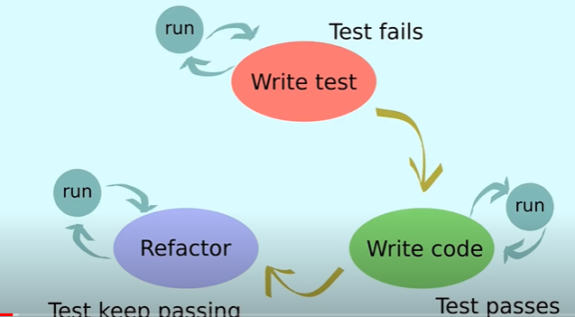

# Project Management

We have followed the agile project management to manage our project which is mostly used to complete the complex projects. This management mainly focuses on the collaboration, flexibility, continuous improvement with standard outcomes which consist of six major deliverables to keep records and complete the project.

## Deliverables of Agile project Management

|  |  |
| --- | --- |
| Product Vision Statement | summary that achieves the goal of project |
| Product Roadmap | high-level view of the requirement to achieve product vision |
| Product Backlog | list of tasks breakdown to complete the project |
| Release Plan | Delivering the product on time. |
| Sprint Backlogs | the goals, user stories process to complete the current sprint and tasks |
| Increment | working functionality shown to the stakeholders. |

## Scrum

Scrum is one of the parts of agile management or methodology. It is an agile framework which follows the ideas of agile software development. Scrum framework is different to others agile methodologies In the term of roles, events and artifacts which it consists to operate.

The scrum team has mainly three roles

|  |  |
| --- | --- |
| Product Owner | Stakeholders and the customers |
| Development Team | Group who delivers the product |
| Scrum Master | Leader who organizes the sprint and scrum is followed. |

The timeframe for the project development and completion was 8 weeks. Since the project followed the scrum methodology, we had scrum master, product owner and development team. we were group of four people in an agile team, so each member had a chance to be scrum master for two weeks and manage the team, scrum, and follow the agile manifest. Every group Member followed the Scrum events and keep the agile cycle continuous and alive to maintain and complete the project.

We strictly followed the scrum events which are as follows:

**Sprint-** we had 8 sprints to be completed and each sprint had a duration of 1 weeks which was recorded with the sprint backlog.

**Sprint planning**- we had a 1 hr weekly meeting within the groups to plan upcoming sprints.

**Daily scrum**-A short conversation and zoom meeting were conducted each day to discuss about the achievements for that day.

**Sprint review**- Our team had a regular weekly meeting with the client/stakeholders to discuss about the sprint and feedback.

The best practises of agile development like continuous integration, customer collaboration, Extreme Programming, Testing, Burndown Charts, and user stories were involved in the development.

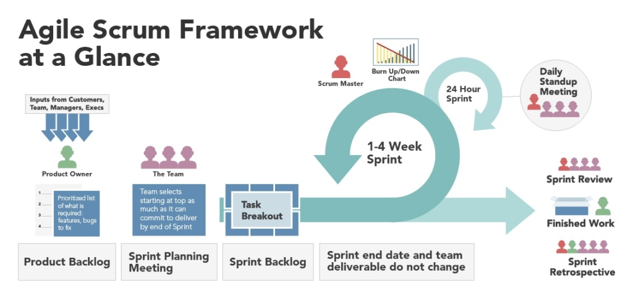

# Software Development Process

It is the process where software development work is divided into different phases to design, develop and testing to provide high quality software. Developing a software itself is a big challenge and difficult, it needs a certain development process to overcome such challenges. Without a certain process, a high-quality software cannot be delivered. So, we also have followed the standard software development process which have been widely used which are as follows.

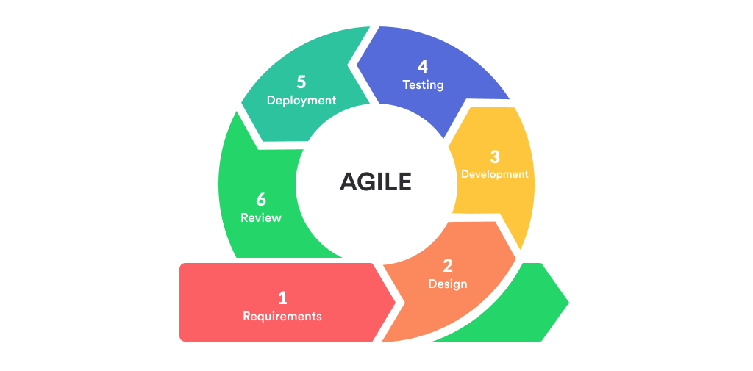

|  |  |
| --- | --- |
| Analysis and planning | It is the beginning which focuses on the scope of project where group/team discusses with the Stakeholders. |
| Requirements/Feasibility analysis | Team gathers all the functional requirements for the software and does the feasibility study. |
| Backlog/Sprints | The requirements are breakdown on task, and backlog and sprints are created to deliver the product on time |
| Design and prototyping | Once the functional requirements are met, prototype is developed as an application architecture |
| Coding/software Development | The development team starts with the coding for the software. |
| Integration/Testing | The testing is done for the built application to check the bugs, errors before production. |
| Releasing/Production/Maintenance | Once the testing is passed, the application is released, and development team monitors the system for maintenance. |

# System Architecture

System architecture describes about the vital components and model of a system and their relationships of interacting with each other’s. It provides the structured view and works as a blueprint of a system. System architecture encompasses decisions as to where to place specific software components. A decent architecture is significant, else it turns out to be increasingly slow costly to include new capacities later on.

## Client server Architecture

Client Server architecture is also known as networking computing model where all the request and services are performed on a distributed network. This architecture consistsof client computers which is kept over a main server where all the requests, services are consumed and server delivers, hosts the resources to the client request. This architecture manages server to hold several client requests at a time and single client can send request to number of servers. This architecture is mainly considered while building the system which requires the separation between the client and server as well as with the functionality.

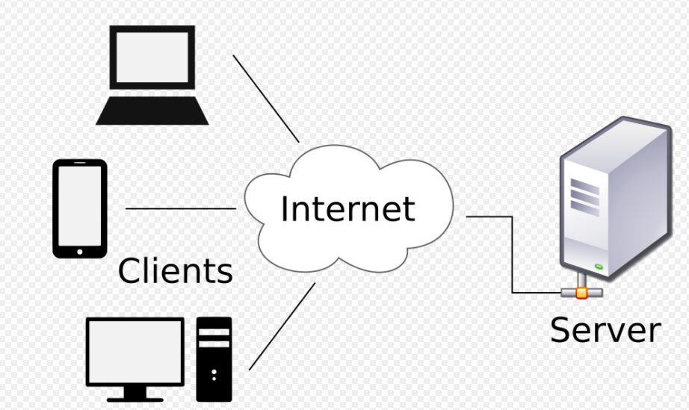

### N-Tier Architecture

N-Tier Architecture which is also known as a layer or Multi-tier architecture is one of the types of client server architecture which has three distinct tiers i.e. presentation tier, logic tier and data tier. This is widely used design for developing the web application which has database tier at the bottom to perform the CRUD operations , presentation tier at the middle to communicate the application logic between client and data and client tier at the top which interacts with the application.

The application was built with the three-tier architecture to give the higher flexibility and security at each level, to keep the business logic distinct from the application.

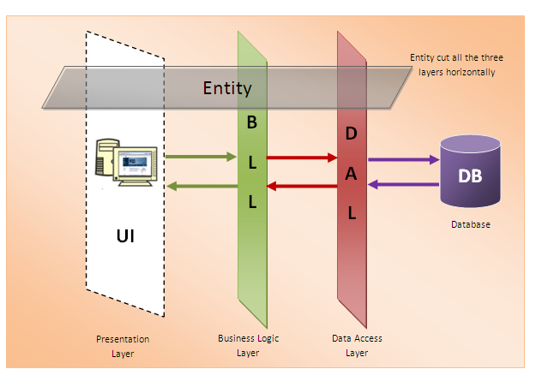

# System Requirements

System requirements is a set of documents which describes the functions, features, specification and behaviour of a system. It is a set of requirements that satisfy the stakeholder needs and requirements.

* We used HTML, PHP, and Blade for making this application
* Laravel platform we used for making this web site
* Three different types of software we used here Php storm for PHP , XAMPP control panel for admin and database connection and phpMyAdmin for database.

## Functional Requirements

The functional requirements are as follows,

* Restaurants will have a portal on which they can register their business.
* Restaurants will be able to enter their business information, update their information.
* Restaurants can add food options and assign categories to the food items (Indian food, Mexican food etc).
* Users will also have an option to sign up and login from the user portal.
* Once user logins, they will be able to select from multiple restaurants and then they can make seat reservations.
* Users can also pre-order food along with seat reservations.
* Users can also select a food category and then it will bring the restaurants which offer that category type.
* After selection of restaurant, user can also see the available reservations.
* Users can also pay for their reservations and food through the web application if they want

## Non-functional requirements:

* The restaurant and user portals should be user-friendly.
* The web application should be secure, and users will not be able to access unauthorized data.
* The web application should be able to serve multiple users at once without lagging or freezing.
* For security, we will use renowned web service provider for our servers.

# Use case diagram

Use case Diagram helps to summarize the relationships between use cases, actors, and systems. It helps to develop the system form the end user’s perspective, helps to visualise the requirements, and validates the system architecture.

## User case Diagram

This diagram illustrates how user will login and use the application

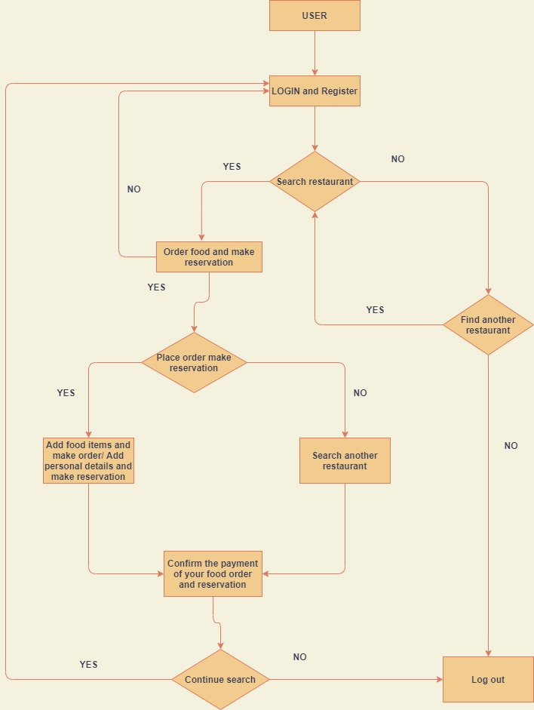

## Admin

This diagram illustrates how admin or restaurant will login and use the web applications to perform functions.

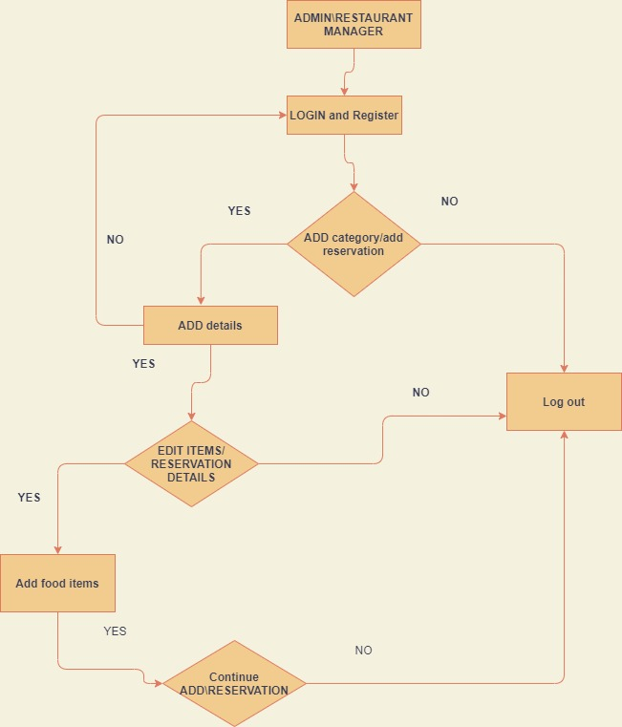

## ERD Diagram

This is the initial version of ERD Diagram, this later evolved to the database tables which changed as per the needs of the client.

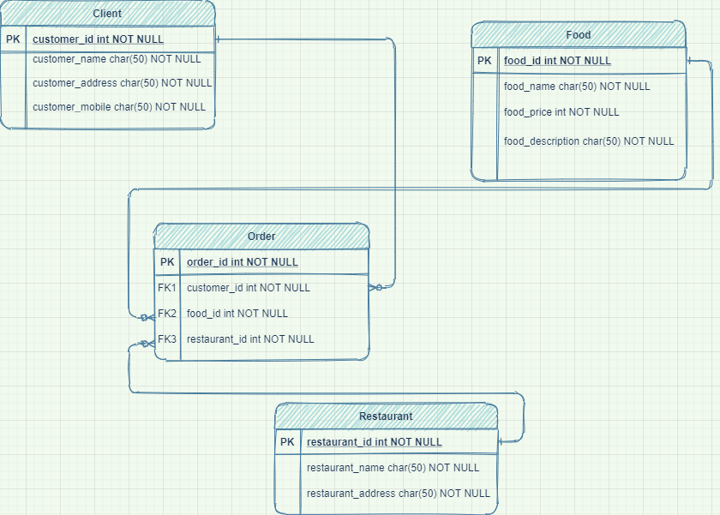

## Web Application diagram

This is a simplified view of our web application.

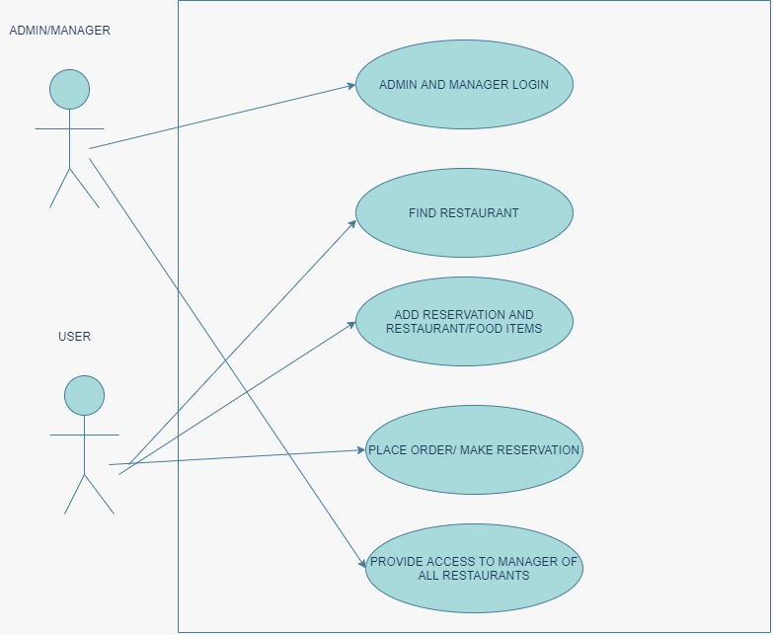

## Prototype

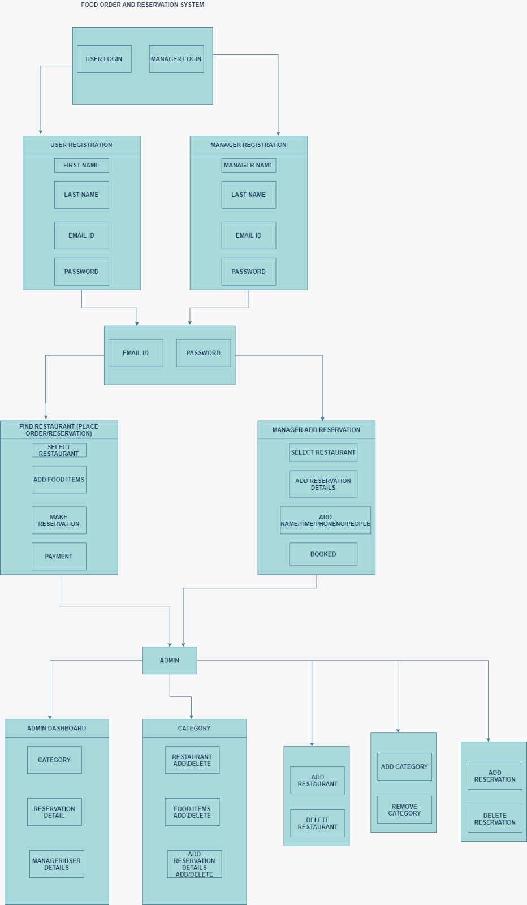

# Backlogs

|  |  |  |  |  |
| --- | --- | --- | --- | --- |
| **Description** | **Responsible member** | **Weeks required** | **Milestone** | **Status** |
| Planning and market analysis | Gaurav, Syed, Wajeeh and Nihal | 1 |  | Done |
| Functional requirements | Syed, Wajeeh and Nihal | 1 | 1 | Done |
| Digital Prototyping | Gaurav |  | 2 | Done |
| Group meeting and discussion | Gaurav, Syed, Wajeeh and Nihal | Every week | Every Sprints | Done |
| Client meeting | Gaurav, Syed, Wajeeh and Nihal | Every Week | Every Sprints | Done |
| sprint tracking and records of meeting | Gaurav, Syed, Wajeeh and Nihal | 19.5 | 1,2,3,4,5,6,7 | Done |
| Database Design | Gaurav, Syed, Wajeeh and Nihal | 1 | 3 | Done |
| Website coding | Gaurav, Syed, Wajeeh and Nihal | 5 | 2-7 | Done |
| Testing | Gaurav, Syed, Wajeeh and Nihal | 2 | 3-7 | Done |
| Refactoring | Gaurav, Syed, Wajeeh and Nihal | 2 | 5-7 | Done |
| Deliver to the client | Gaurav, Syed, Wajeeh and Nihal |  |  | Will be delivered on 12 October 2020 |
| Documentation | Gaurav, Syed, Wajeeh and Nihal | 2 | 5-7 | Done |

# Sprints/client meetings

## Client meeting 1:

|  |  |  |  |  |  |  |  |  |  |  |
| --- | --- | --- | --- | --- | --- | --- | --- | --- | --- | --- |
| **WEEKLY PROGRESS REPORT**  **Date: 17TH August 2020**   |  |  | | --- | --- | | **Project Name** | Online Food and Restaurant Reservation | | **Client** | Dr. Charles Yeo | | **Milestone (Sprint Number)** | **1** | | **Milestone (Sprint Status)** | **In Progress** |  Activities Completed This Week 1. Decided on functional and non-functional requirements. 2. Market Research. 3. Decided the tech stack (Php, SQL, Responsive Web) Issues for Immediate Attention Get approval for functional and non-functional requirements. Activities for Next week 1. Install PHP and Laravel Flask. 2. Setup the database SQL. 3. Design database entities, their attributes and the relation between them. 4. Design of the application. Feedback from the Client Good work keeps progressing.       |  |  | | --- | --- | | **Status: Approved** | **Client’s Signature:** | |

## Client meeting 2:

**WEEKLY PROGRESS REPORT**

|  |  |  |  |  |  |  |  |  |  |  |
| --- | --- | --- | --- | --- | --- | --- | --- | --- | --- | --- |
| **Date: 24TH August 2020**   |  |  | | --- | --- | | **Project Name** | Online Food and Restaurant Reservation | | **Client** | Dr. Charles Yeo | | **Milestone (Sprint Number)** | **2** | | **Milestone (Sprint Status)** | **In Progress** |  Activities Completed This Week 1. Design the Application flow. 2. Design the prototype. 3. Design the database model and ER Diagram. Issues for Immediate Attention Get feedback on the application and database design. Activities for Next week 1. Implement Database design on backend. 2. Write Test cases for Database Schema. Feedback from the Client        |  |  | | --- | --- | | **Status: Approved / Not Approved** | **Client’s Signature:** | |
|  |

## Client meeting 3:

|  |  |  |  |  |  |  |  |  |  |  |
| --- | --- | --- | --- | --- | --- | --- | --- | --- | --- | --- |
| **WEEKLY PROGRESS REPORT**  **Date: 31st August 2020**   |  |  | | --- | --- | | **Project Name** | Online Food and Restaurant Reservation | | **Client** | Dr. Charles Yeo | | **Milestone (Sprint Number)** | **3** | | **Milestone (Sprint Status)** | **In Progress** |  Activities Completed This Week 1. Implemented the database design on backend Issues for Immediate Attention Get feedback on the database implementation Activities for Next week 1. Front end template for the website. Feedback from the Client        |  |  | | --- | --- | | **Status: Approved / Not Approved** | **Client’s Signature:** | |

## Client meeting 4:

|  |  |  |  |  |  |  |  |  |  |  |
| --- | --- | --- | --- | --- | --- | --- | --- | --- | --- | --- |
| **WEEKLY PROGRESS REPORT**  **Date: 7TH September 2020**   |  |  | | --- | --- | | **Project Name** | Online Food and Restaurant Reservation | | **Client** | Dr. Charles Yeo | | **Milestone (Sprint Number)** | **4** | | **Milestone (Sprint Status)** | **In Progress** |  Activities Completed This Week 1. Front end template ready for the website Issues for Immediate Attention Show the frontend to client and see if changes required. Activities for Next week 1. Implement user signup and login 2. Implement restaurant signup and login Feedback from the Client        |  |  | | --- | --- | | **Status: Approved / Not Approved** | **Client’s Signature:** | |
|  |

## Client meeting 5:

|  |  |  |  |  |  |  |  |  |  |  |
| --- | --- | --- | --- | --- | --- | --- | --- | --- | --- | --- |
| **WEEKLY PROGRESS REPORT**  **Date: 14TH September 2020**   |  |  | | --- | --- | | **Project Name** | Online Food and Restaurant Reservation | | **Client** | Dr. Charles Yeo | | **Milestone (Sprint Number)** | **5** | | **Milestone (Sprint Status)** | **In Progress** |  Activities Completed This Week 1. Implemented user signup and login 2. Added restaurant signup and login Issues for Immediate Attention Give user/restaurant signup login demo. Activities for Next week 1. Add forgot password feature to the website user portal. 2. Add forgot password feature to the website restaurant portal. 3. Make password secure (upper and lower case letters) Feedback from the Client        |  |  | | --- | --- | | **Status: Approved / Not Approved** | **Client’s Signature:** | |

## Client meeting 6:

|  |  |  |  |  |  |  |  |  |  |  |
| --- | --- | --- | --- | --- | --- | --- | --- | --- | --- | --- |
| **WEEKLY PROGRESS REPORT**  **Date: 28TH September 2020**   |  |  | | --- | --- | | **Project Name** | Online Food and Restaurant Reservation | | **Client** | Dr. Charles Yeo | | **Milestone (Sprint Number)** | **6** | | **Milestone (Sprint Status)** | **In Progress** |  Activities Completed This Week 1. Home page Navigation bar improved 2. Added search button for restaurant search (need to work on backend) 3. Increased password security, password should be 8 characters with special characters Issues for Immediate Attention Give demo for restaurant seat reservation Activities for Next week 1. Implement search restaurant functionality 2. Checkout functionality for food items Feedback from the Client        |  |  | | --- | --- | | **Status: Approved / Not Approved** | **Client’s Signature:** | |

## Client meeting 7:

|  |  |  |  |  |  |  |  |  |  |  |
| --- | --- | --- | --- | --- | --- | --- | --- | --- | --- | --- |
| **WEEKLY PROGRESS REPORT**  **Date: 5TH October 2020**   |  |  | | --- | --- | | **Project Name** | Online Food and Restaurant Reservation | | **Client** | Dr. Charles Yeo | | **Milestone (Sprint Number)** | **7** | | **Milestone (Sprint Status)** | **In Progress** |  Activities Completed This Week 1. Added seat reservation feature. 2. Restaurants can see, edit and remove seat reservations. Issues for Immediate Attention Add feature so that seat reservation is not spammed or all seats booked by single person Activities for Next week 1. Add food order feature. 2. Add checkout page on food order and seat reservation. Feedback from the Client        |  |  | | --- | --- | | **Status: Approved / Not Approved** | **Client’s Signature:** | |

# Software testing

Software testing is the process performed to check the functionality of the software developed meets all the client requirements and to ensure the developed software is defect free for the production.

## Compatibility Testing

This is a software testing to ensure whether an application can run on different operating system, hardware, and mobile devices.

We performed compatibility testing and found out that our website is compatible with other browsers and OS since we used Bootstrap and latest updated libraries.

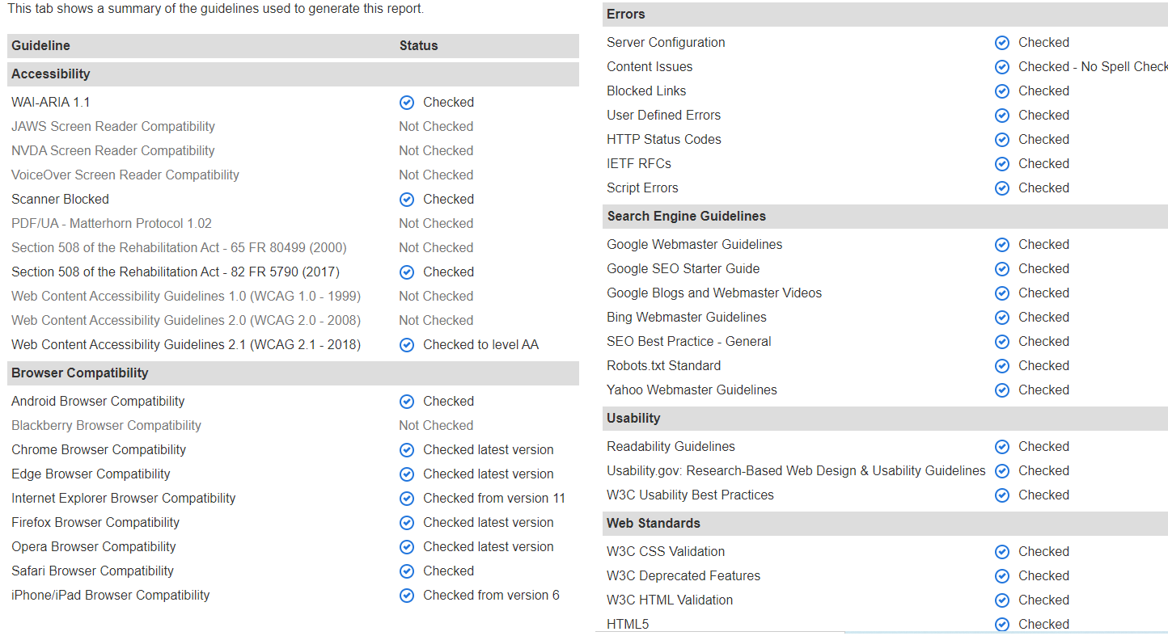

## Functional testing

This is a software testing a kind of Black Box testing which is done to ensure the functionality of a system or an application runs as expected and as per the functional requirements.

1. User register testing (Front- end)

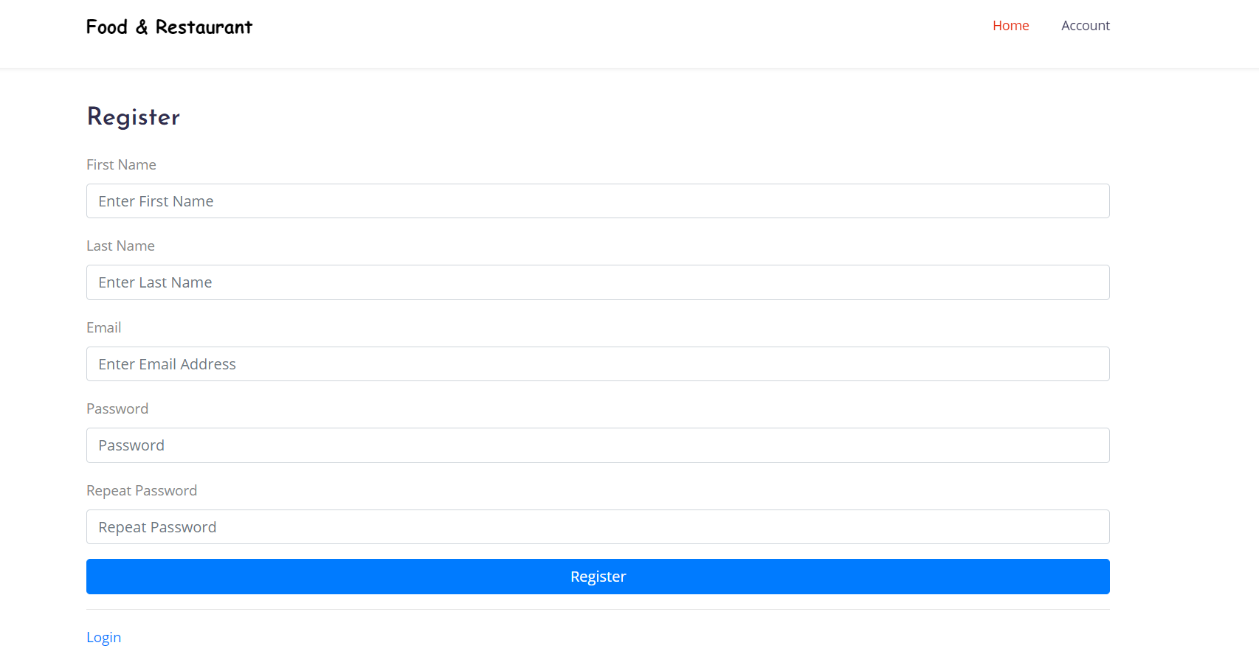

1. User register testing passed

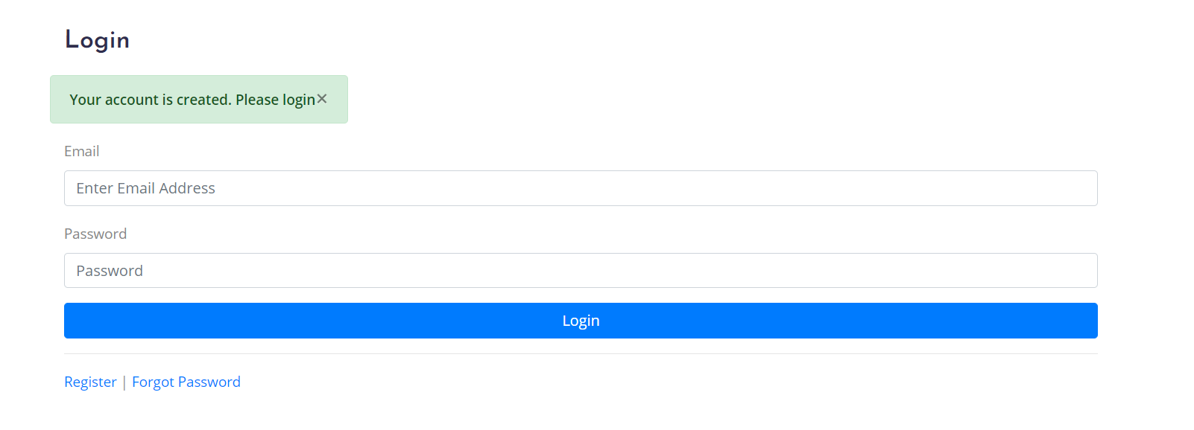

1. User login success testing

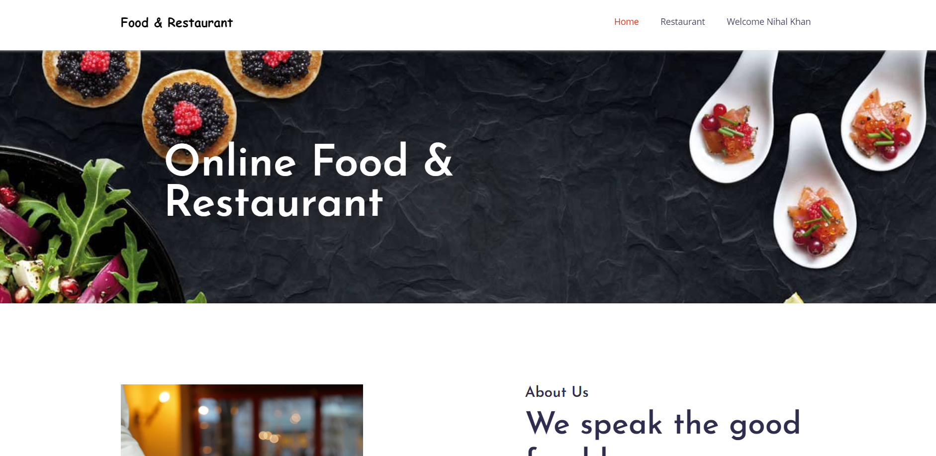

1. User login Failed if you would enter Wrong email id and password

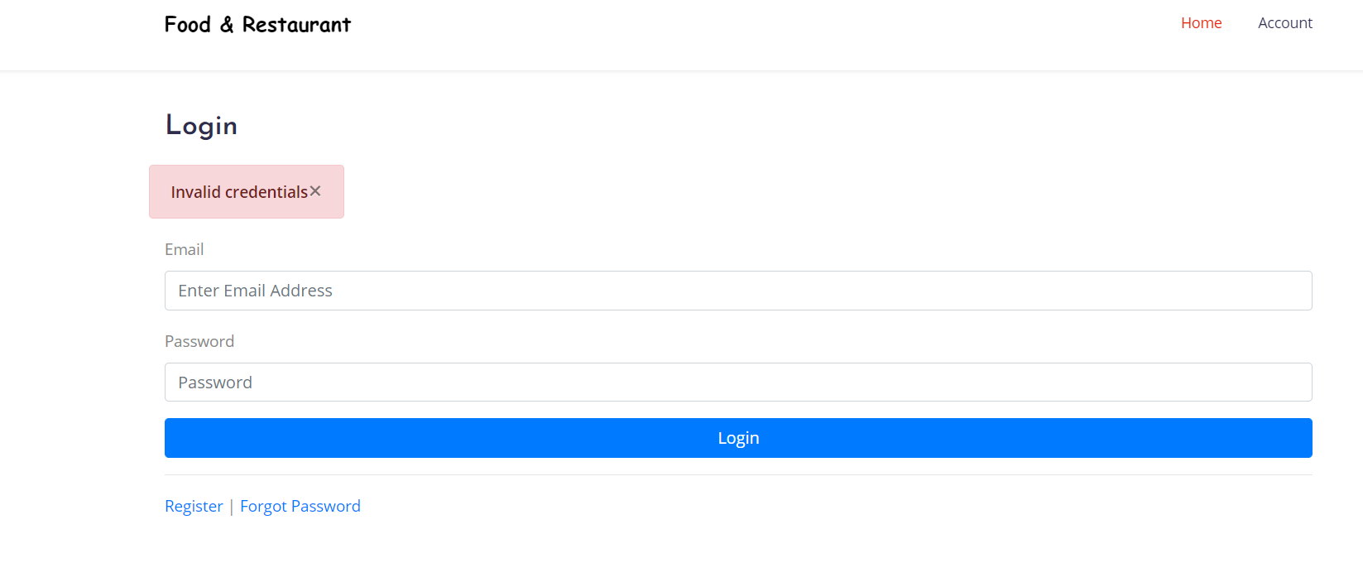

1. Searching for restaurants

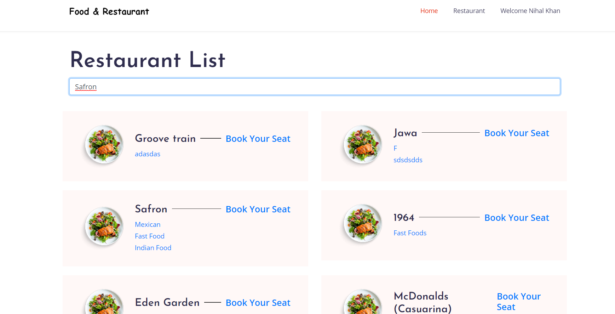

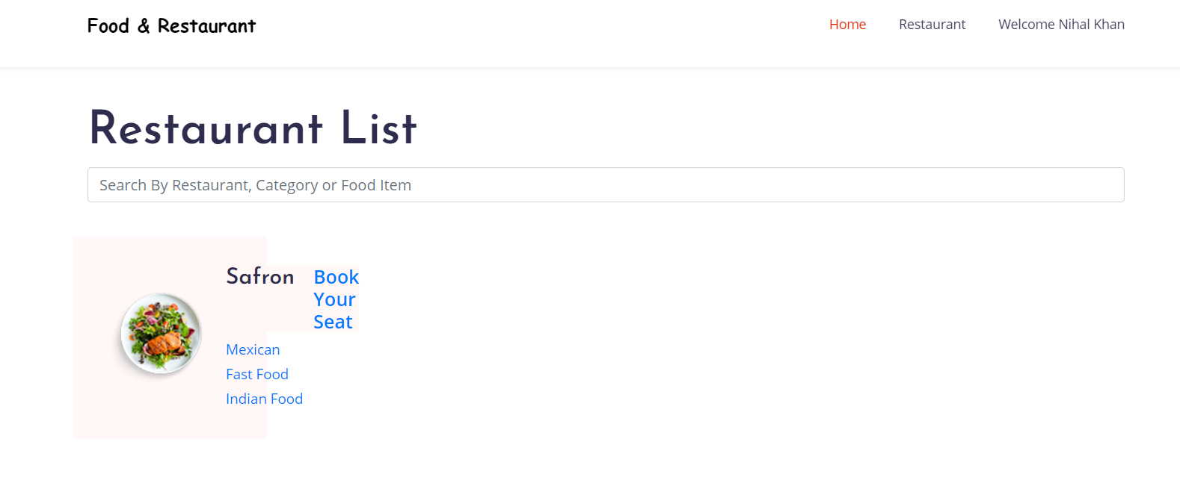

1. Testing for reservation

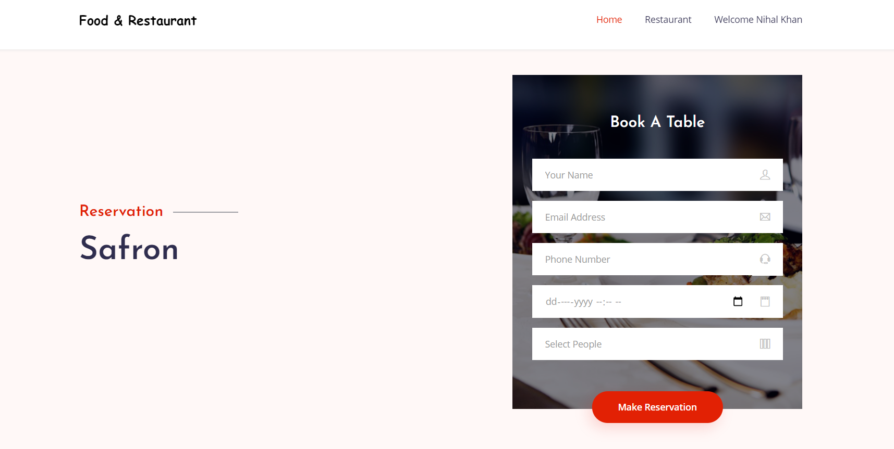

1. Admin Login testing (Back-end)

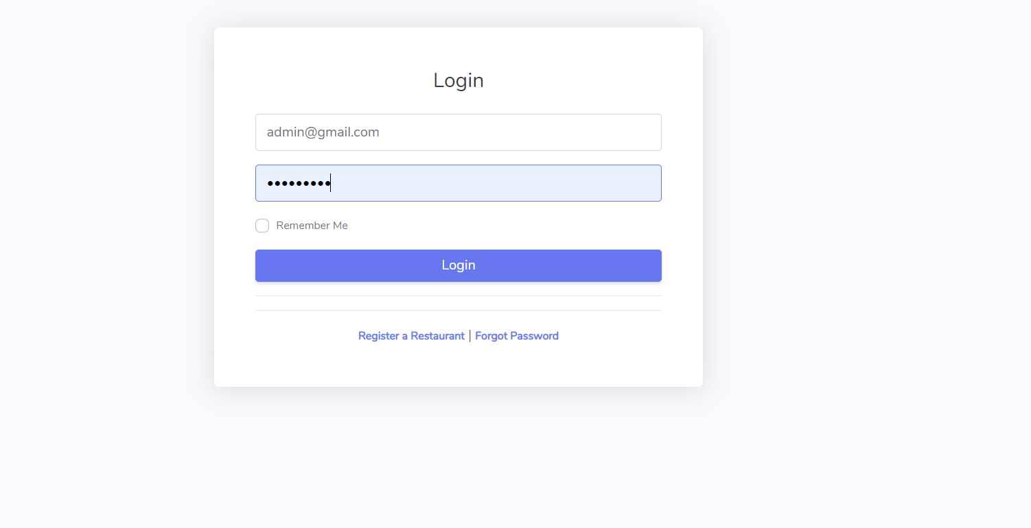

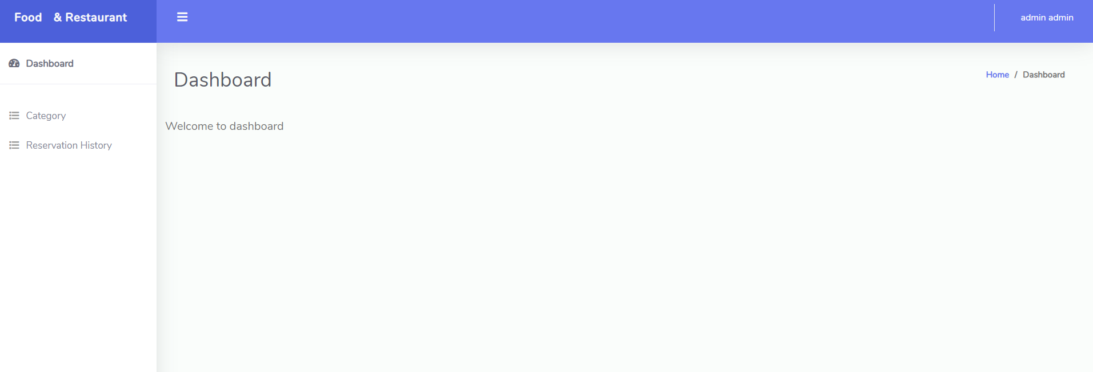

1. Testing add category and reservation module

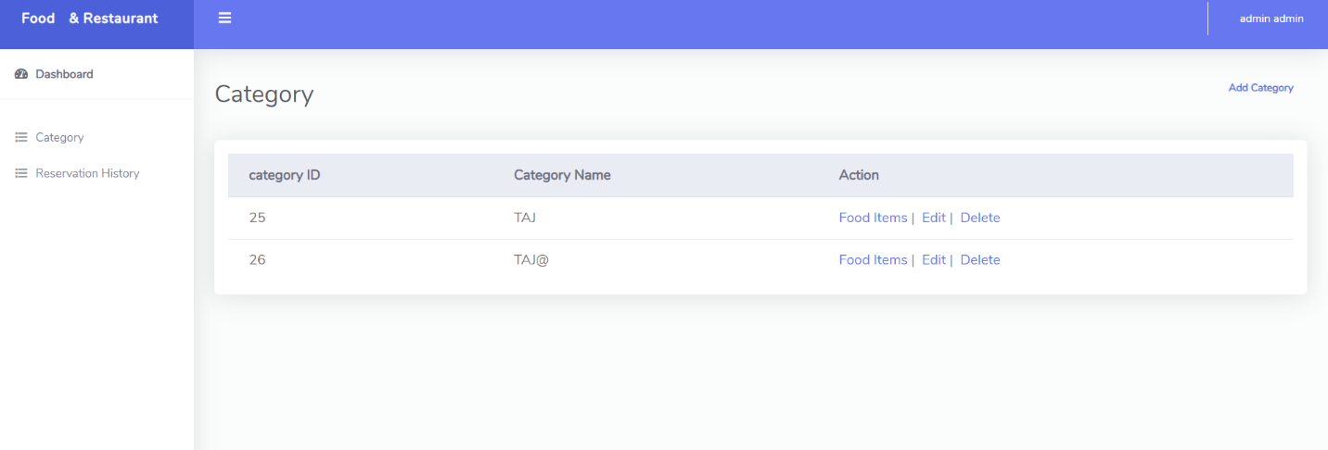

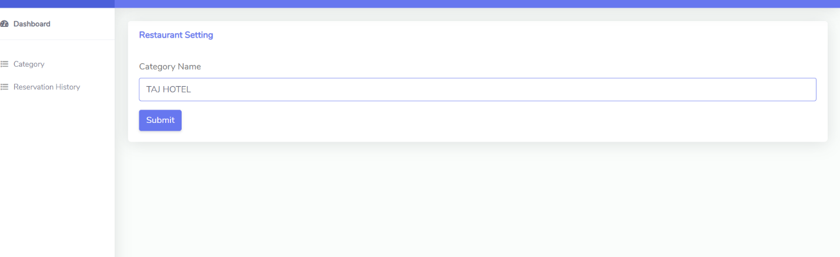

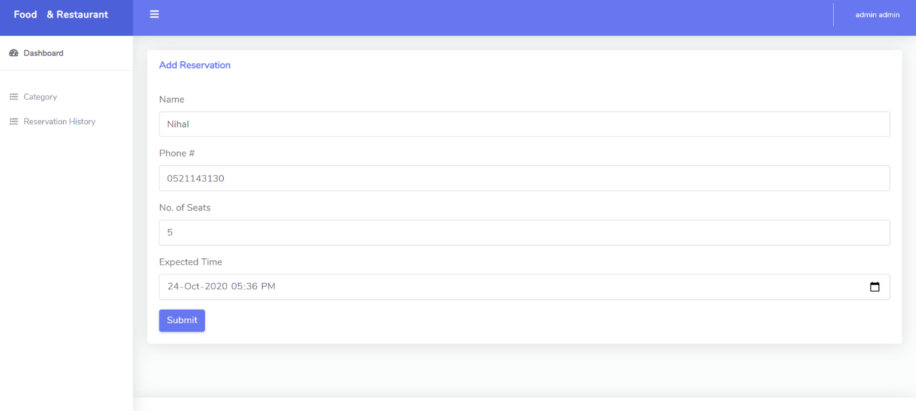

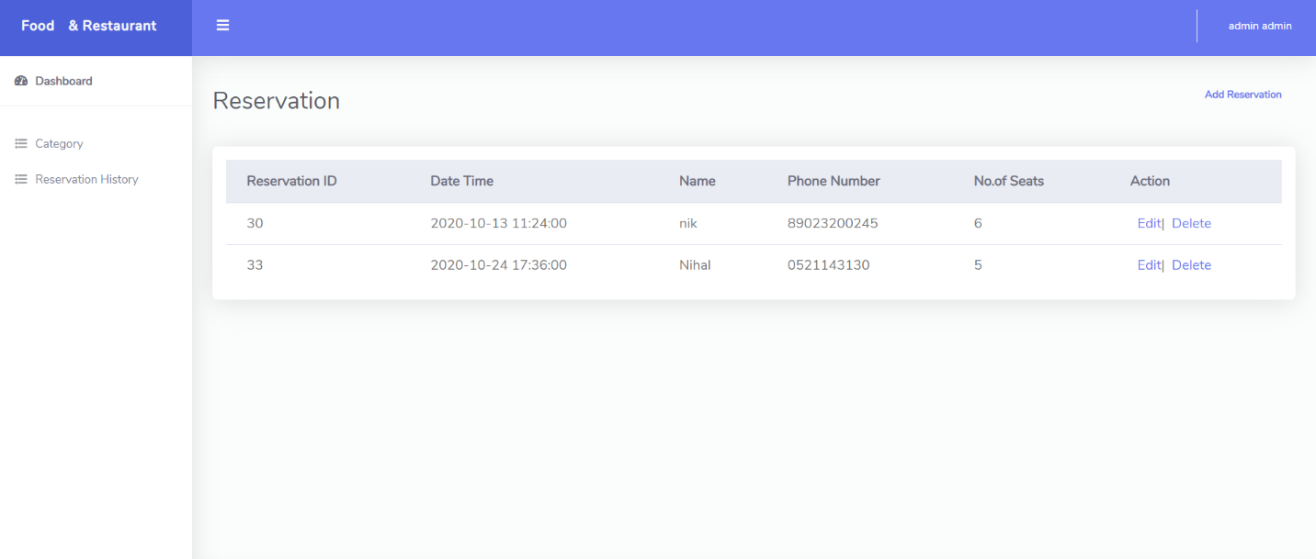

1. Testing of setting, change password

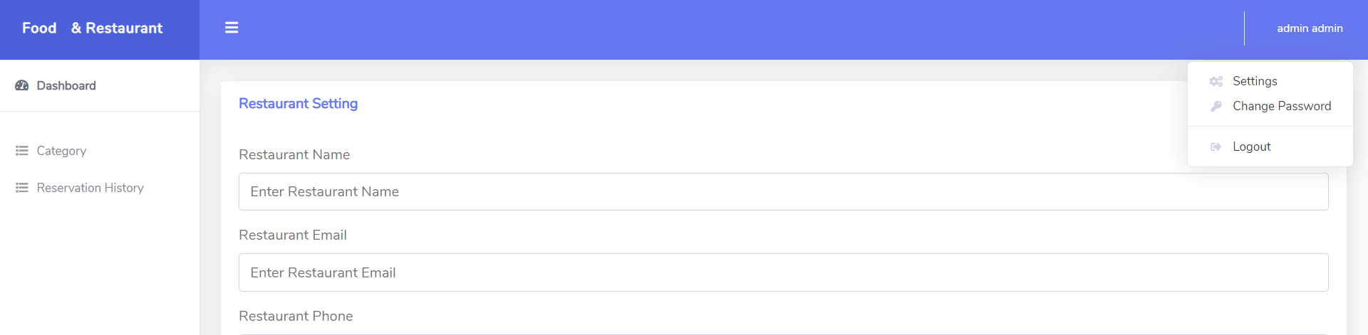

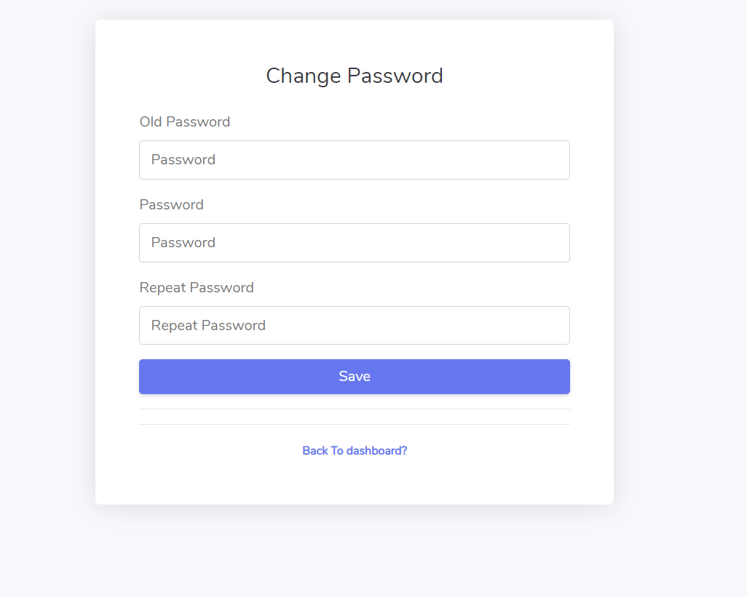

1. Login error when someone try to login as admin

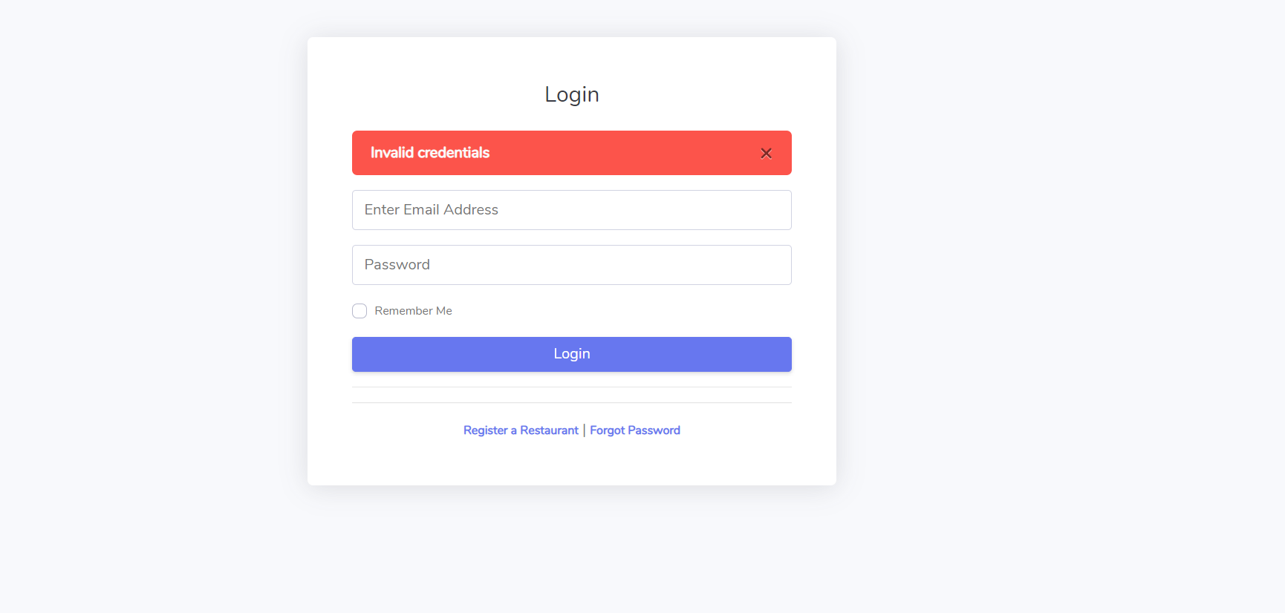

### Test Case #01

|  |  |
| --- | --- |
| Project Name | Online Food and Restaurant Reservation |
| Client | Dr. Charles Yeo |
| Test Case Number | **1** |
| Priority | High |
| Test Case Title | User Signup Testing |
| Test Case Details  When the user visits the website, he should be able to visit the user signup portal by clicking on the navigation bar. Once user clicks on the navigation bar, User will be prompted to ask if he wants to login or signup. If user clicks signup, a signup form should be displayed with the following attributes: 1. First Name 2. Last Name 3. Email 4. Password 5. Repeat Password 6. Register (BUTTON)  Once user registers successfully, he should be redirected to login page and success message should be displayed. | |
| Acceptance criteria | User should be able to visit signup page 2. Successful signup after clicking register button. 3. Redirection to login page after signup. |
| Test Result | Test Case Successful as per acceptance criteria |

### Test Case #02

|  |  |
| --- | --- |
| Project Name | Online Food and Restaurant Reservation |
| Client | Dr. Charles Yeo |
| Test Case Number | 2 |
| Priority | High |
| Test Case Title | User Login Testing |
| Test Case Details  When the user visits the website, he should be able to visit the user login portal by clicking on the navigation bar. Once user clicks on the navigation bar, User will be prompted to ask if he wants to login or signup. If user clicks login, a login form should be displayed with the following attributes: 1. Email 2. Password 3. Login (BUTTON)  Once user logins successfully, he should be redirected to the main page from where he should be search. | |
| Acceptance Criteria | 1.User should be able to visit login page 2. Successful login after clicking login button. 3. Redirection to home page after login. |
| Test Result | Test Case Successful as per acceptance criteria |

### Test Case #03

|  |  |
| --- | --- |
| Project Name | Online Food and Restaurant Reservation |
| Client | Dr. Charles Yeo |
| Test Case Number | 1 |
| Priority | High |
| Test Case Title | Restaurant Signup Testing |
| Test Case Details  When the restaurant visits the website, they should be able to visit the restaurant signup portal by clicking on the navigation bar. Once restaurant clicks on the navigation bar, restaurant will be prompted to ask if they wants to login or signup. If restaurant clicks signup, a signup form should be displayed with the following attributes: 1. First Name 2. Last Name 3. Email 4. Password 5. Repeat Password 6. Register (BUTTON)  Once restaurant registers successfully, they should be redirected to login page and success message should be displayed. | |
| Acceptance criteria | 1.Restaurant should be able to visit signup page 2. Successful signup after clicking register button. 3. Redirection to login page after signup. |
| Test Result | Test Case Successful as per acceptance criteria |

### Test Case #04

|  |  |
| --- | --- |
| Project Name | Online Food and Restaurant Reservation |
| Client | Dr. Charles Yeo |
| Test Case Number | 1 |
| Priority | High |
| Test Case Title | RestaurantLogin Testing |
| Test Case Details  When the restaurant visits the website, he should be able to visit the restaurant login portal by clicking on the navigation bar. Once restaurant clicks on the navigation bar, User will be prompted to ask if he wants to login or signup. If user clicks login, a login form should be displayed with the following attributes: 1. Email 2. Password 3. Login (BUTTON)  Once restaurant logins successfully, he should be redirected to the main page from where he should be able to add categories and menu items. | |
| Acceptance criteria | 1.Restaurant should be able to visit Login page 2. Successful signup after clicking register button. 3. Redirection to dashboard after login. |
| Test Result | Test Case Successful as per acceptance criteria |

# 

### Test Case #05

|  |  |
| --- | --- |
| Project Name | Online Food and Restaurant Reservation |
| Client | Dr. Charles Yeo |
| Test Case Number | 1 |
| Priority | High |
| Test Case Title | User forgot password Testing |
| Test Case Details  When the user visits the website, he should be able to visit the user login portal by clicking on the navigation bar. Once user clicks on the navigation bar, User will be prompted to ask if he wants to login or signup. If user clicks login, a login form should be displayed which has forgot password link. Once user clicks forgot password, he should be asked to enter 1. Email Address  Once user enters the email address, he should receive a new password on their email from which they can back login to account. | |
| Acceptance criteria | 1 User should be able to visit login page 2. User should be redirected to forgot password page once clicked on FORGOT PASSWORD 3. User should receive a password on their email.  4. User should login after using the sent password on email |
| Test Result | Test Case Successful as per acceptance criteria |

### Test Case #06

|  |  |
| --- | --- |
| Project Name | Online Food and Restaurant Reservation |
| Client | Dr. Charles Yeo |
| Test Case Number | 1 |
| Priority | High |
| Test Case Title | Restaurant forgot password Testing |
| Test Case Details  When the restaurant visits the website, he should be able to visit the restaurant login portal by clicking on the navigation bar. Once restaurant clicks on the navigation bar, Restaurant will be prompted to ask if he wants to login or signup. If restaurant clicks login, a login form should be displayed which has forgot password link. Once restaurant clicks forgot password, he should be asked to enter 1. Email Address  Once restaurant enters the email address, he should receive a new password on their email from which they can back login to account. | |
| Acceptance criteria | 1 Restaurant should be able to visit login page 2. Restaurant should be redirected to forgot password page once clicked on FORGOT PASSWORD 3. Restaurant should receive a password on their email.  4. Restaurant should login after using the sent password on email |
| Test Result | Test Case Successful as per acceptance criteria |

### Test Case #07

|  |  |
| --- | --- |
| Project Name | Online Food and Restaurant Reservation |
| Client | Dr. Charles Yeo |
| Test Case Number | 1 |
| Priority | High |
| Test Case Title | Restaurant add food category |
| Test Case Details  Once the restaurant logins from their portal, they should be able to see a category tab on their dashboard.  After clicking on category, they should be able to see already added categories list. Restaurant should also be able to see “Add Category” button from where they can add new ones.  After clicking “Add Category”, restaurant should be asked category name for new category.  After entering category name and clicking on submit restaurant can add the category. | |
| Acceptance criteria | 1. Restaurant should be able to see categories tab on their dashboard. 2. Restaurant should be able to see already added categories list. 3. Restaurant should be able to add a new category.  4.Error message should be displayed if already exist. |
| Test Result | Test Case Successful as per acceptance criteria |

### Test Case #08

|  |  |
| --- | --- |
| Project Name | Online Food and Restaurant Reservation |
| Client | Dr. Charles Yeo |
| Test Case Number | 1 |
| Priority | High |
| Test Case Title | Restaurantupdating food category Testing |
| Test Case Details  Once the restaurant logins from their portal, they should be able to see a category tab on their dashboard.  After clicking on category, they should be able to see already added categories list. Restaurant should also be able to see “edit” button from where they can edit existing ones.  After clicking “edit”, restaurant should be asked category name for new category.  After entering category name and clicking on submit restaurant can add the category. | |
| Acceptance criteria | 1.Restaurant should be able to see categories tab on their dashboard. 2. Restaurant should be able to see already added categories list. 3. Restaurant should be able to add a new category.  4.Error message should be displayed if already exist. |
| Test Result | Test Case Successful as per acceptance criteria |

### Test Case #09

|  |  |
| --- | --- |
| Project Name | Online Food and Restaurant Reservation |
| Client | Dr. Charles Yeo |
| Test Case Number | 1 |
| Priority | High |
| Test Case Title | Restaurant adding food on category Testing |
| Test Case Details  Once the restaurant logins from their portal, they should be able to see a category tab on their dashboard.  After clicking on category, they should be able to see already added categories list. Upon clicking on a category, restaurant will be shown the food items in that category. Restaurant should also be able to see “Add Food Item” button from where they can add new ones.  After clicking “Add Food item”, restaurant should be asked: 1. Food item name 2. Food item price After entering these details, restaurant can add food to the category | |
| Acceptance criteria | 1.Restaurant should be able to see categories tab on their dashboard. 2. Restaurant should be able to see already added categories list. 3. Restaurant should be able to add a food on a category.  4.Error message should be displayed if already exist. |
| Test Result | Test Case Successful as per acceptance criteria |

### Test Case #10

|  |  |
| --- | --- |
| Project Name | Online Food and Restaurant Reservation |
| Client | Dr. Charles Yeo |
| Test Case Number | 1 |
| Priority | High |
| Test Case Title | Restaurant updating food items on category Testing |
| Test Case Details  Once the restaurant logins from their portal, they should be able to see a category tab on their dashboard.  After clicking on category, they should be able to see already added categories list. Upon clicking on a category, restaurant will be shown the food items in that category. Restaurant should also be able to see “Update Food Item” or “Edit” button from where they update the name or price of food item.  After clicking “Edit”, restaurant should be asked: 1. New Food item name 2. New Food item price  After entering these details, restaurant submits the new details of food item and database is updated | |
| Acceptance criteria | 1.Restaurant should be able to see categories tab on their dashboard. 2. Restaurant should be able to see already added categories list. 3. Restaurant should be able to update a food which is on category.  4.Error message should be displayed if already exist. |
| Test Result | Test Case Successful as per acceptance criteria |

### Test Case #11

|  |  |
| --- | --- |
| Project Name | Online Food and Restaurant Reservation |
| Client | Dr. Charles Yeo |
| Test Case Number | **1** |
| Priority | High |
| Test Case Title | Restaurant Seat reservationlisting Testing |
| Test Case Details  Once the restaurant logins from their portal, they should be able to see a Reservation History tab on their dashboard.  After clicking on reservation history, they should be able to see already reserved seats.  This page will show following things:  1. Date Time of reservation 2. Name of customer 3. Phone number of customers 4. Number of seats booked 5. Update/Delete reservation option | |
| Acceptance criteria | 1.Restaurant should be able to see reservation history tab on their dashboard. 2. Restaurant should be able to see already reserved seats list.  3.Resteraunt should be able to add a reservation as well. |
| Test Result | Test Case Successful as per acceptance criteria |

### Test Case #12

|  |  |
| --- | --- |
| Project Name | Online Food and Restaurant Reservation |
| Client | Dr. Charles Yeo |
| Test Case Number | 1 |
| Priority | High |
| Test Case Title | Restaurant Seat reservation update Testing |
| Test Case Details  Once the restaurant logins from their portal, they should be able to see a Reservation History tab on their dashboard.  After clicking on reservation history, they should be able to see already reserved seats. Once they click on edit reservation, they should be able to change following information:  1. Date Time of reservation 2. Name of customer 3. Phone number of customers 4. Number of seats booked | |
| Acceptance criteria | 1. Restaurant should be able to see reservation history tab on their dashboard.  2. Restaurant should be able to see already reserved seats list.  3. Restaurant should be able to update a reservation if they want |
| Test Result | Test Case Successful as per acceptance criteria |

### Test Case #13

|  |  |
| --- | --- |
| Project Name | Online Food and Restaurant Reservation |
| Client | Dr. Charles Yeo |
| Test Case Number | 1 |
| Priority | High |
| Test Case Title | User seat Reservation for restaurant Testing |
| Test Case Details  Once a user logins from their portal, they should be able to see Restaurant tab. After restaurant clicks on restaurant tab, they will see all the registered restaurants.  Users should be able to click “Book Your Seat” option with the restaurant, which takes them to reservation form. Reservation form has following attributes: 1. Name 2. Email 3. Phone number 4. Date and time 5. Number of people  After clicking submit, seat is booked. | |
| Acceptance criteria | 1.Users should be able to click “Book your seat”  2. User should be shown success message when seat is booked.  3. User should be given confirmation message through email. |
| Test Result | Test Case Successful as per acceptance criteria |

## Usability Testing

In simple Usability testing is a testing which ensures how much the application Is restaurant friendly. In this testing, a group of restaurants are asked to perform certain functionality on the interfaces and feedback are recorded to improve the restaurant interface.

1. Open login page testing

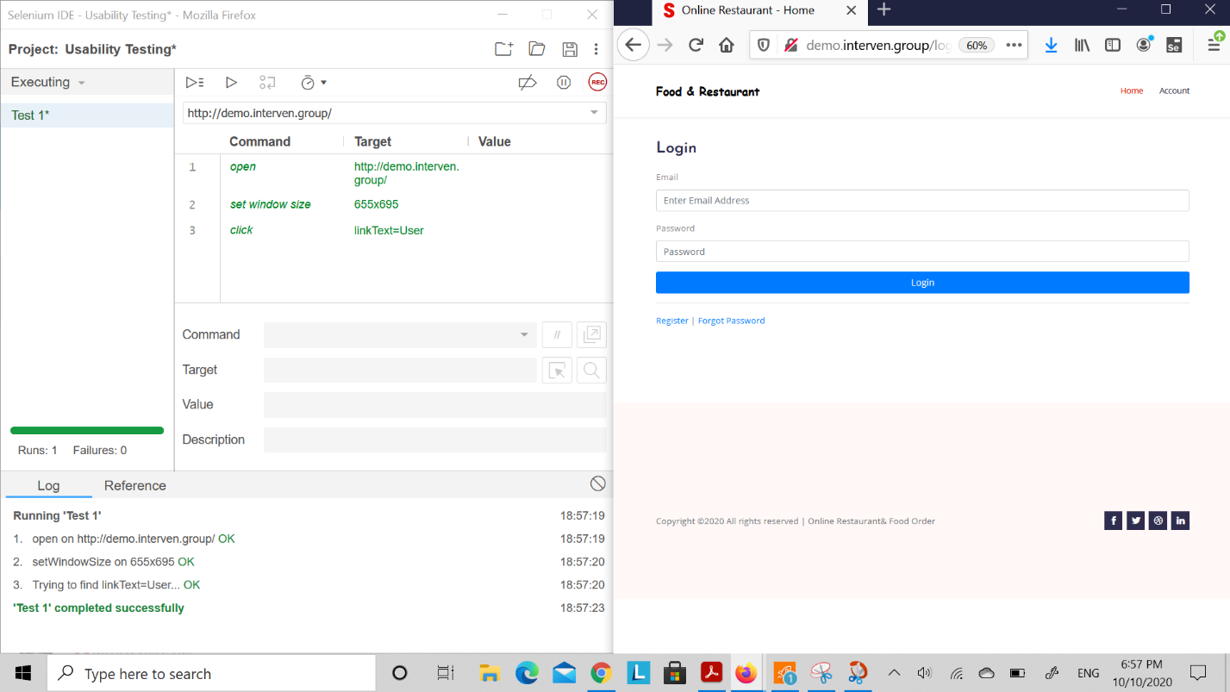

1. User Registration testing

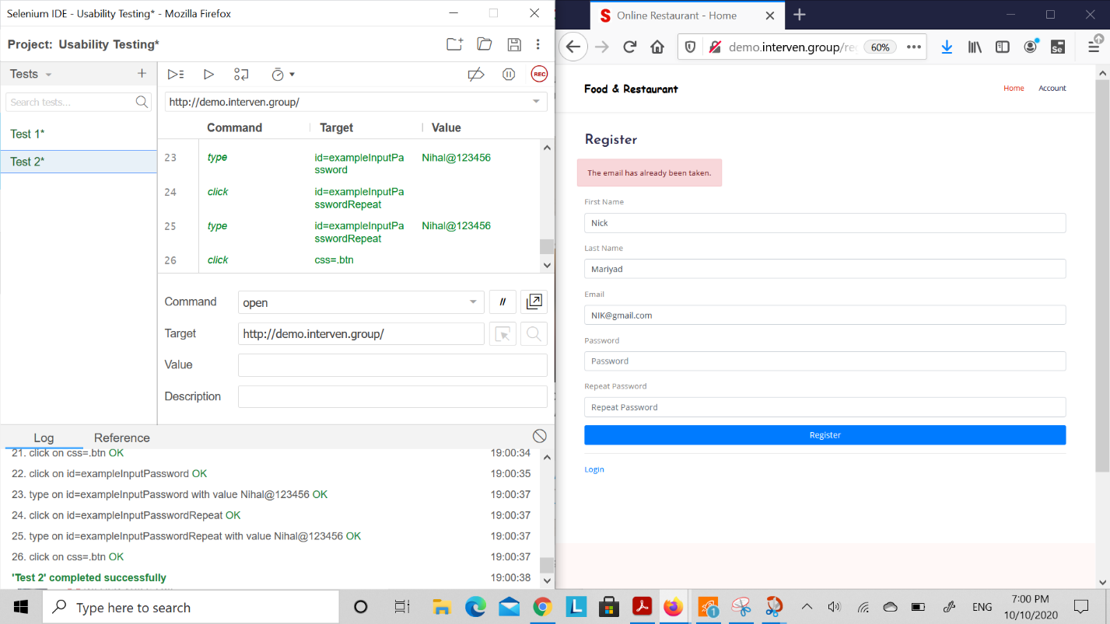

1. Successful login testing

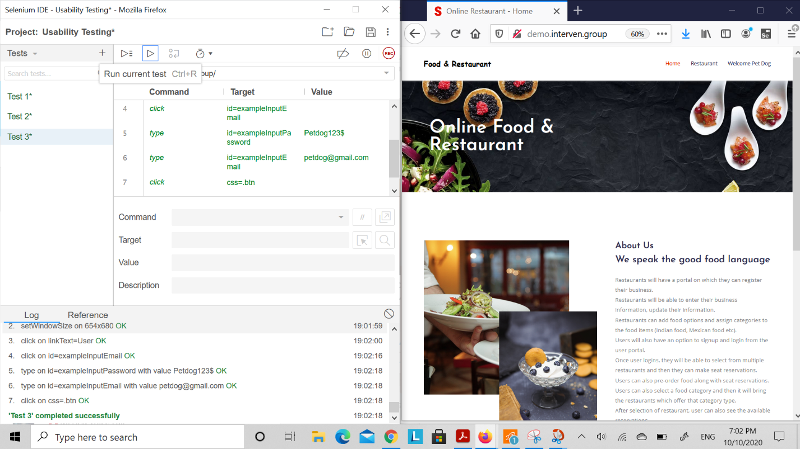

1. Reservation Page testing

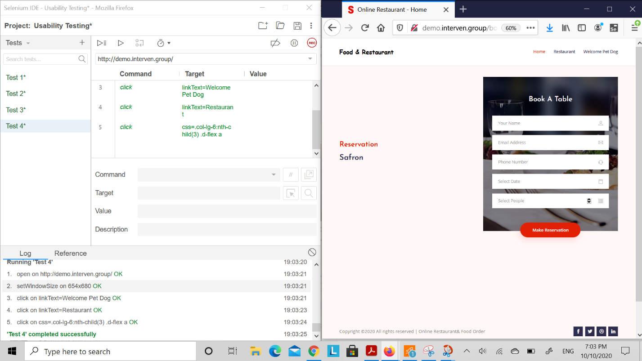

1. Successfully Reservation

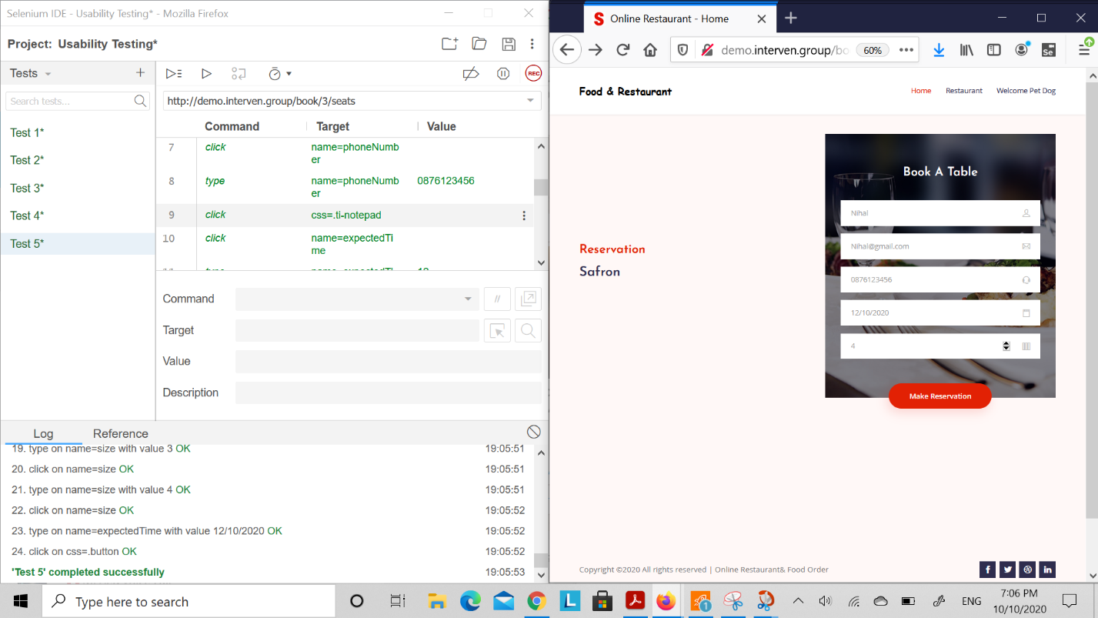

1. Admin Page testing (Back-end)

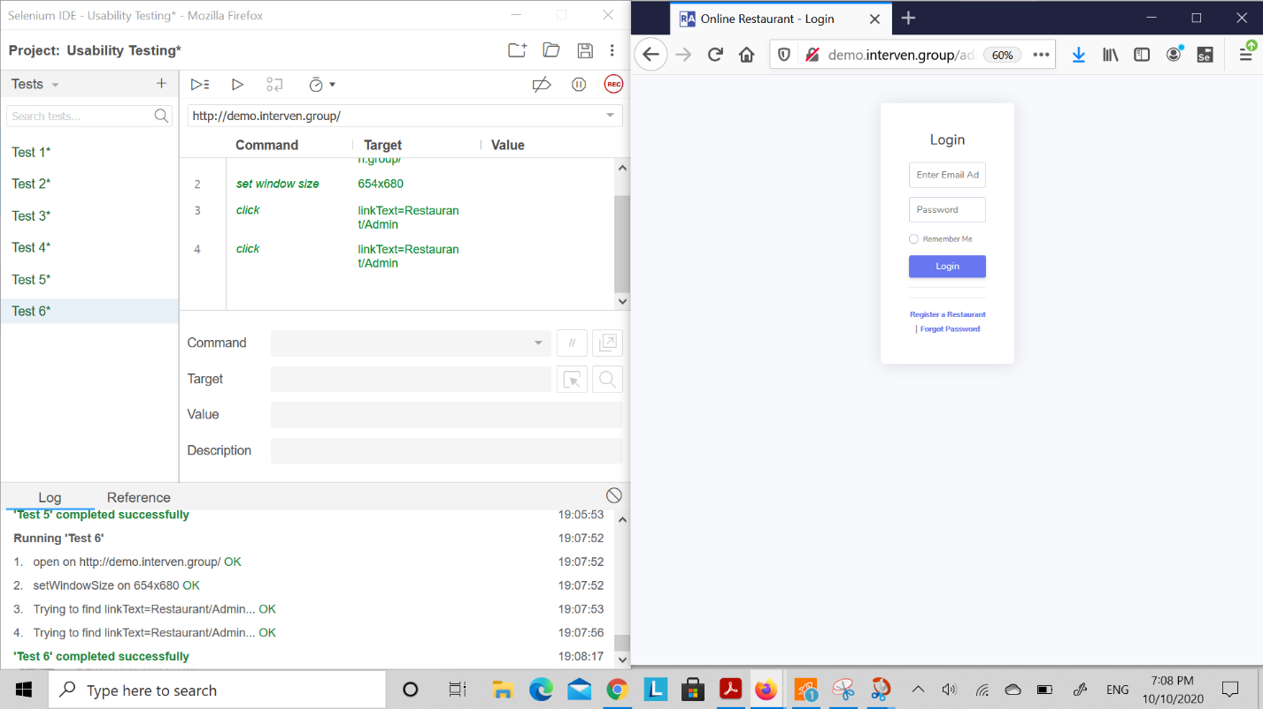

1. Admin panel Registration page testing

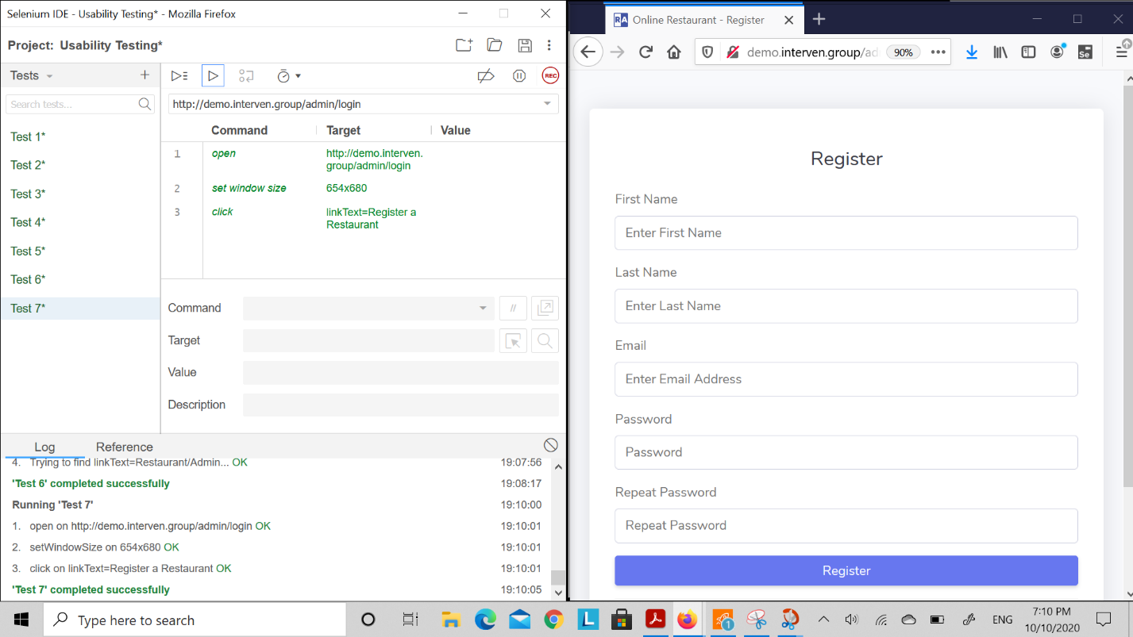

1. Restaurant Registration successful testing

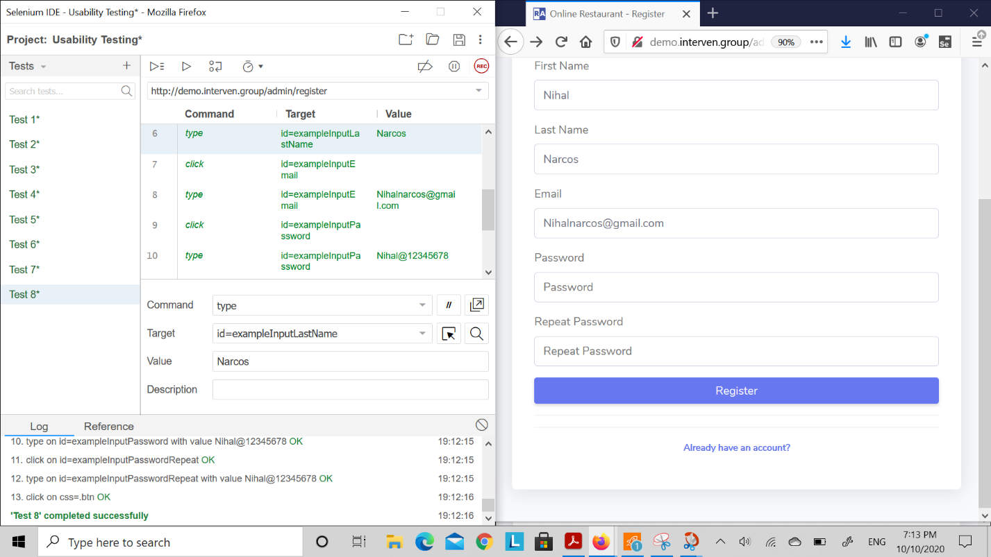

1. Successful login into backend testing

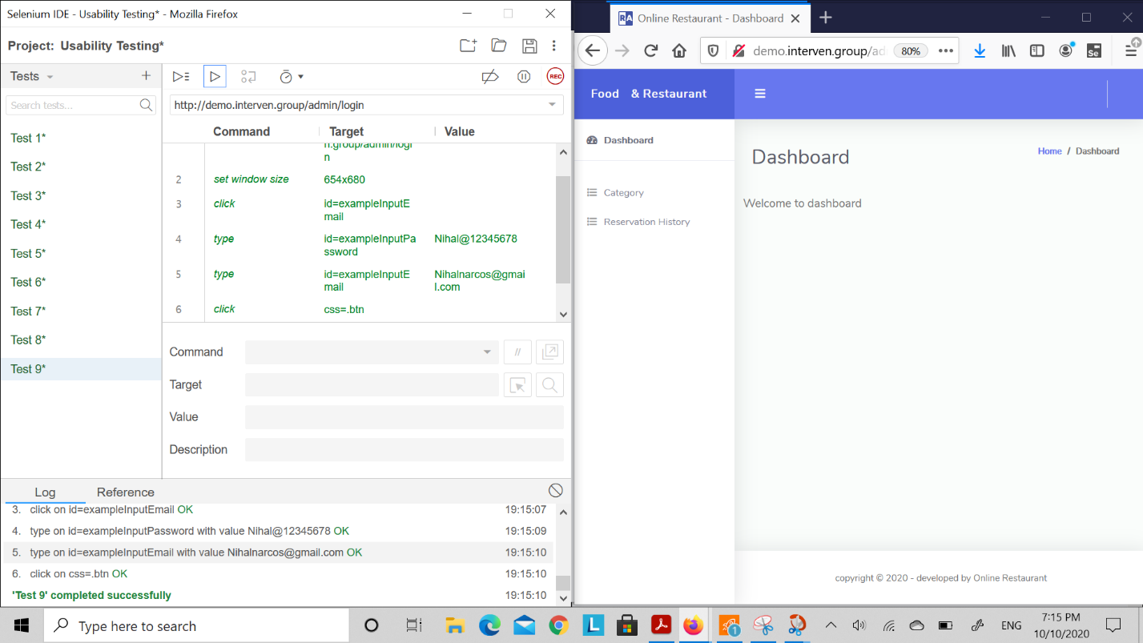

1. Add category or add restaurant from backend testing successful

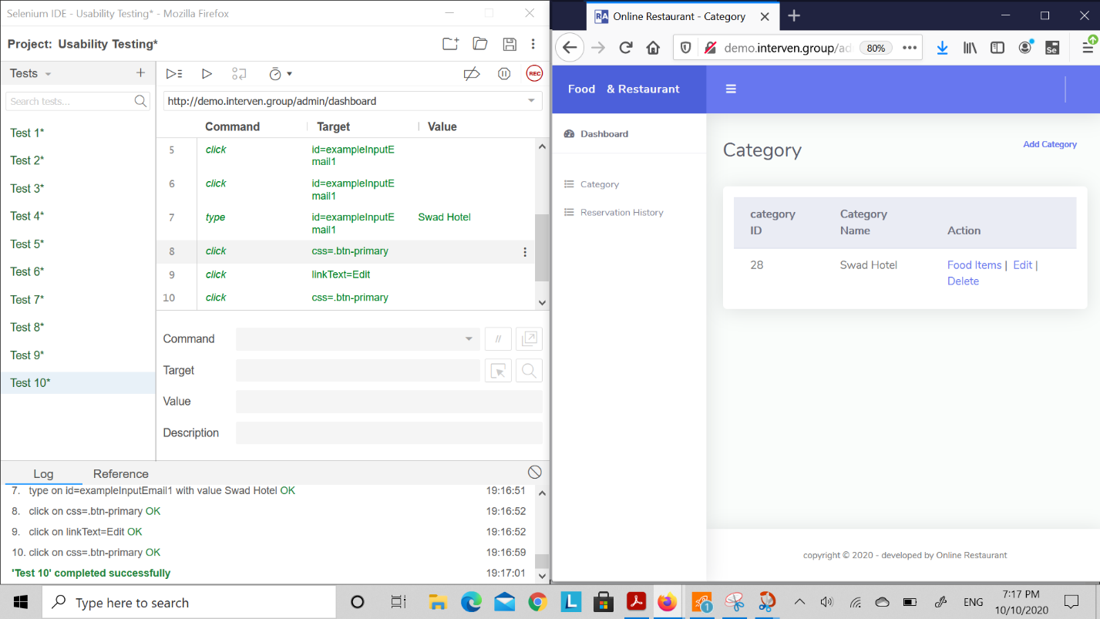

1. Add Reservation for customer testing succesful

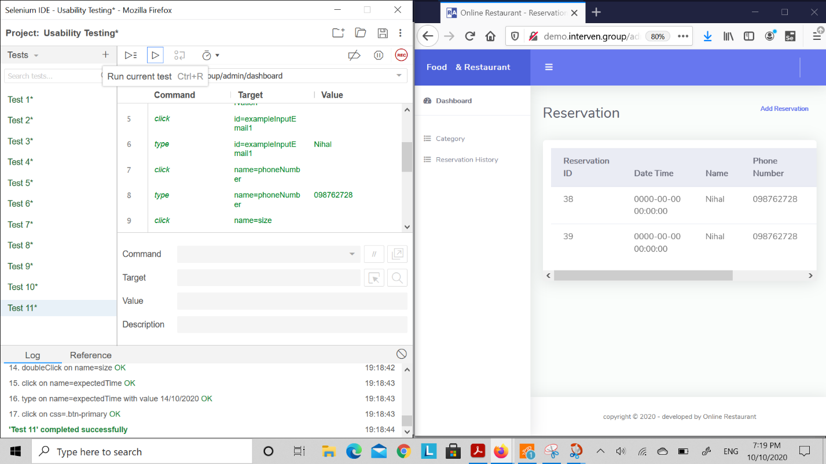

1. Password changed option testing

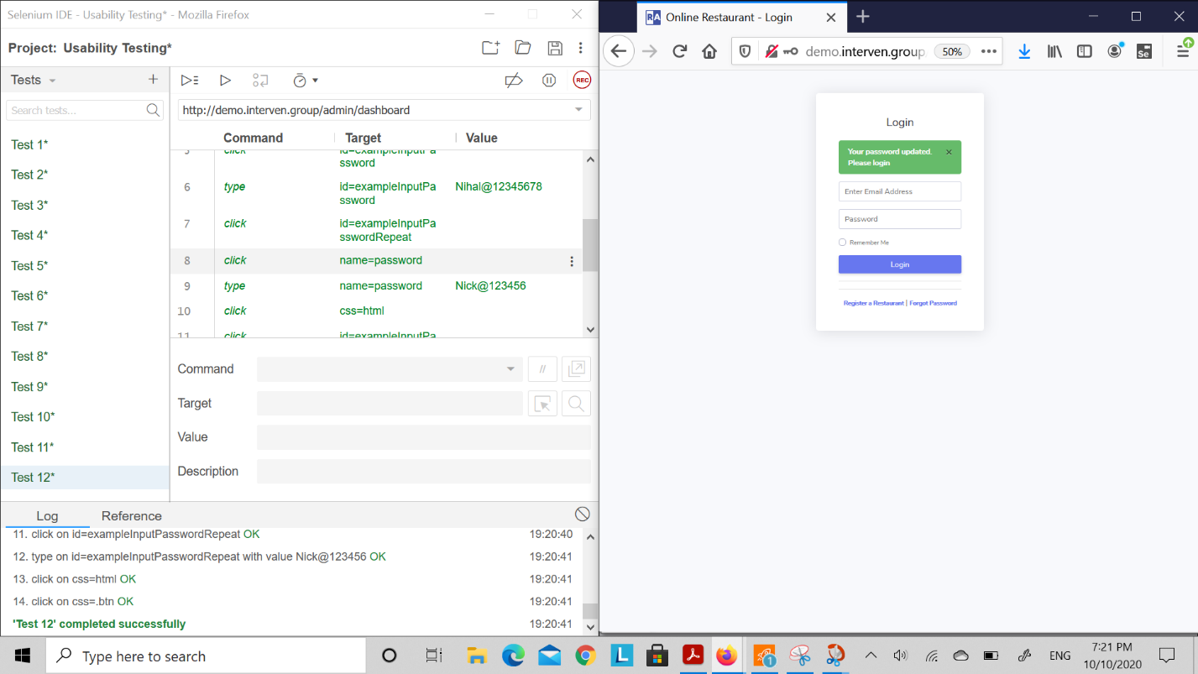

1. Order summary testing (Add food items, quantity, and checkout option)

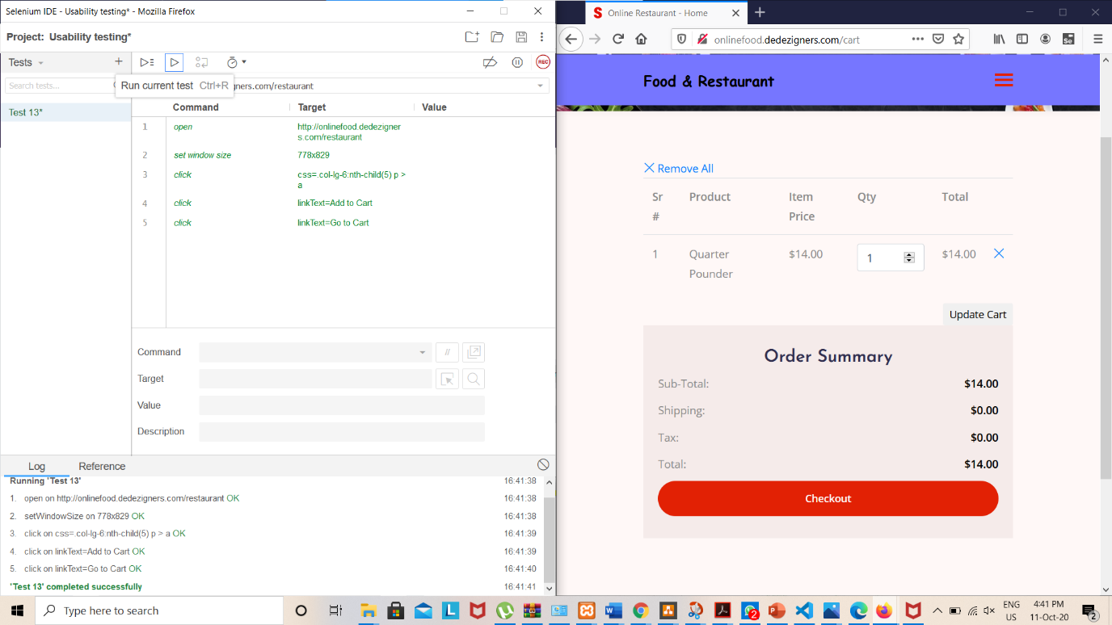

1. Payment option testing

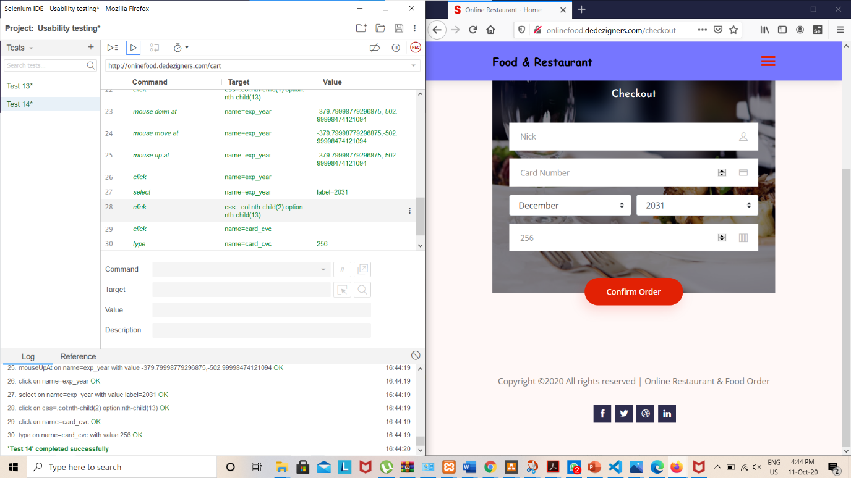

## Security Testing

It is a testing performed to find the vulnerabilities, threats, risk in an application which helps to prevent Malicious attack. It identifies all the loopholes and weakness of a system which might cause loss of information. With these testing, software developers can fix the weakness and loophole with the testing.

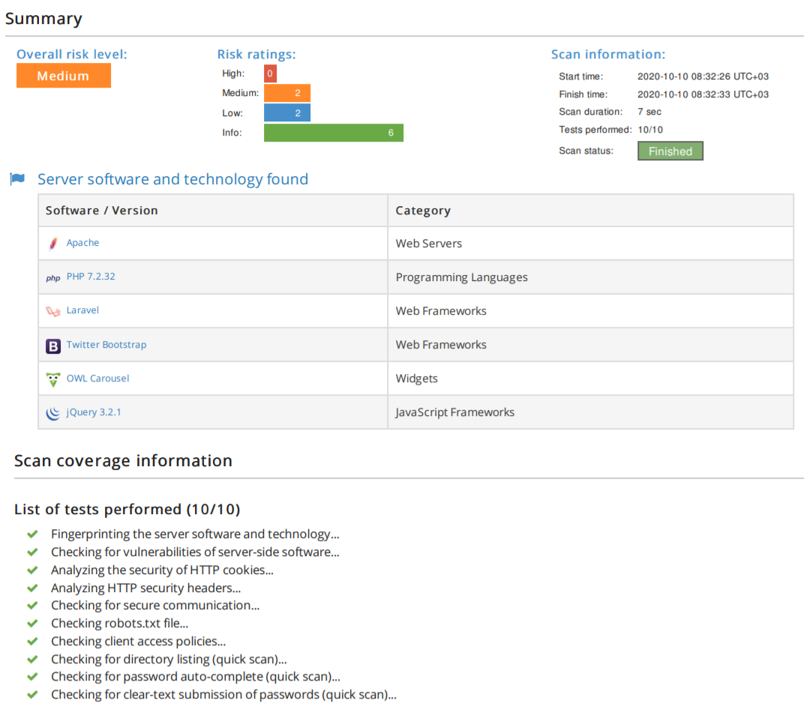

## **Performance Testing**

We performed performance testing and following were the results:  
The only problem we had was the usage of hosting which is not near Australian region.

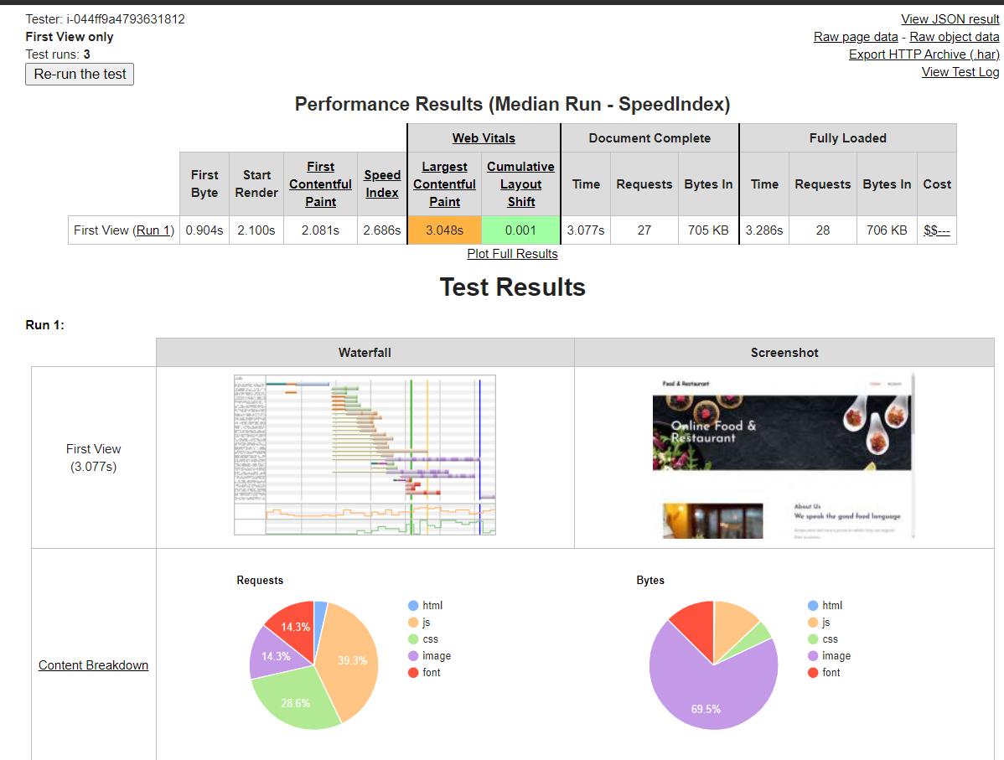

## Test cases for TDD

The following test cases were performed.

### **1. User Login Pass:**

<?php

class Example extends PHPUnit\_Extensions\_SeleniumTestCase

{

protected function setUp()

{

$this->setBrowser("\*chrome");

$this->setBrowserUrl("http://onlinefood.dedezigners.com/");

}

public function testMyTestCase()

{

$this->open("/food and restaurent/login.blade.php");

$this->click("name=user");

$this->waitForPageToLoad("30000");

$this->type("id=email-id", "Name@gmail.com");

$this->type("id=password", "Nik@12345678");

$this->click("css=input[type=\"submit\"]");

$this->waitForPageToLoad("30000");

}

}

?>

### **2. Restaurent admin Login Pass:**

<?php

class Example extends PHPUnit\_Extensions\_SeleniumTestCase

{

protected function setUp()

{

$this->setBrowser("\*chrome");

$this->setBrowserUrl("http://onlinefood.dedezigners.com/");

}

public function testMyTestCase()

{

$this->open("/food and restaurent/login.php");

$this->click("name=user");

$this->waitForPageToLoad("30000");

$this->type("id=email-id", "Name@gmail.com");

$this->type("id=password", "Nik@12345678");

$this->click("css=input[type=\"submit\"]");

$this->waitForPageToLoad("30000");

}

}

?>

### **3. Adding Category Details**

<?php

class Example extends PHPUnit\_Extensions\_SeleniumTestCase

{

protected function setUp()

{

$this->setBrowser("\*chrome");

$this->setBrowserUrl("http://onlinefood.dedezigners.com/");

}

public function testMyTestCase()

{

$this->open("/food and restaurent/addCategory.php");

$this->click("//section[@id='login-homepage-bg']/div/p/a[2]/button");

$this->waitForPageToLoad("30000");

$this->type("id=username", "Name@gmail.com");

$this->type("id=password", "Nik@12345678");

$this->click("css=input[type=\"submit\"]");

$this->waitForPageToLoad("30000");

$this->click("link=add category");

$this->waitForPageToLoad("30000");

$this->click("css=button.close");

$this->click("link=ADD CATEGORY NAME");

$this->waitForPageToLoad("30000");

$this->type("id=C\_name", "xyz");

$this->type("id=C\_items", "ANY FOOD");

$this->type("id=C-edit", "ANY@gmail.com");

$this->type("id=u\_contact\_no", "045206420");

$this->select("id=C\_name", "label=TAJ HOTEL");

$this->select("id=C\_items", "label=PASTA");

$this->select("id=C\_edit", "label=RESTAURENT NAME");

$this->click("name=submit");

$this->waitForPageToLoad("30000");

$this->click("link=Log Out");

$this->waitForPageToLoad("30000");

}

}

?>

### **4. Admin Login Failed**

<?php

class Example extends PHPUnit\_Extensions\_SeleniumTestCase

{

protected function setUp()

{

$this->setBrowser("\*chrome");

$this->setBrowserUrl("http://onlinefood.dedezigners.com/");

}

public function testMyTestCase()

{

$this->open("/food & restaurent/admin/index.php");

$this->type("name=Email-id", "anydummy@gmail.com");

$this->type("name=password", "123456");

$this->click("//button[@type='submit']");

$this->waitForPageToLoad("30000");

}

}

?>

### **5. Food & restaurant Login Success**

<?php

class Example extends PHPUnit\_Extensions\_SeleniumTestCase

{

protected function setUp()

{

$this->setBrowser("\*chrome");

$this->setBrowserUrl("http://onlinefood.dedezigners.com/");

}

public function testMyTestCase()

{

$this->open("/food and restaurent/register.php");

$this->click("//section[@id='login-homepage-bg']/div/p/a[2]/button");

$this->waitForPageToLoad("30000");

$this->type("id=email-id", "Name@gmail.com");

$this->type("id=password", "Nik@12345678");

$this->click("css=input[type=\"submit\"]");

$this->waitForPageToLoad("30000");

$this->click("link=View more");

$this->waitForPageToLoad("30000");

$this->click("link=Log Out");

$this->waitForPageToLoad("30000");

}

}

?>

### **6. Food and restaurant Reservation**

<?php

class Example extends PHPUnit\_Extensions\_SeleniumTestCase

{

protected function setUp()

{

$this->setBrowser("\*chrome");

$this->setBrowserUrl("http://onlinefood.dedezigners.com/");

}

public function testMyTestCase()

{

$this->open("/food and restaurent/index.php");

$this->click("//section[@id='login-homepage-bg']/div/p/a[2]/button");

$this->waitForPageToLoad("30000");

$this->click("link=Book seat");

$this->waitForPageToLoad("30000");

$this->type("id=Username", "Aksh");

$this->type("id=emailid", "Aksh@gmail.com");

$this->type("id=passwordsignup", "Aksh@123456");

$this->type("id=Phone Number", "0542359897");

$this->type("id=Calender", "25 oct,11:30 pm");

$this->type("id=Select People", "2");

$this->click("css=input[type=\"Make reservation\"]");

$this->waitForPageToLoad("30000");

}

}

?>

### **7. Food and restaurant Finding restaurant**

<?php

class Example extends PHPUnit\_Extensions\_SeleniumTestCase

{

protected function setUp()

{

$this->setBrowser("\*chrome");

$this->setBrowserUrl("http://onlinefood.dedezigners.com/");

}

public function testMyTestCase()

{

$this->open("/food & restaurent/index.php");

$this->click("name=restaurent list");

$this->waitForPageToLoad("30000");

$this->type("id=username", "Name@gmail.com");

$this->type("id=password", "Nik@12345678");

$this->click("css=input[type=\"submit\"]");

$this->waitForPageToLoad("30000");

$this->select("id=Restaurent\_list", "label=Restaurent");

$this->click("id=press enter");

}

}

?>

### 8. Testing of change password of user

<?php

class Example extends PHPUnit\_Extensions\_SeleniumTestCase

{

protected function setUp()

{

$this->setBrowser("\*chrome");

$this->setBrowserUrl("http://onlinefood.dedezigners.com/");

}

public function testMyTestCase()

{

$this->open("/food and restaurent/changepassword.php");

$this->click("name=user");

$this->waitForPageToLoad("30000");

$this->type("id=old password", "Nik@12345678");

$this->type("id=password", "Nik@123456789");

$this->type("id=repeat password", "Nik@123456789");

$this->click("css=input[type=\"save\"]");

$this->waitForPageToLoad("30000");

}

}

?>

### **9. Forgot password testing**

<?php

class Example extends PHPUnit\_Extensions\_SeleniumTestCase

{

protected function setUp()

{

$this->setBrowser("\*chrome");

$this->setBrowserUrl("http://onlinefood.dedezigners.com/");

}

public function testMyTestCase()

{

$this->open("/food and restaurent/forgotpassword.php");

$this->click("name=user");

$this->waitForPageToLoad("30000");

$this->click("link=exact:Forgot Password");

$this->waitForPageToLoad("30000");

$this->type("id=email id", "Name@@gmail.com");

$this->click("css=input[type=\"save\"]");

$this->waitForPageToLoad("30000");

}

}

?>

### **10. Restaurant user Registration**

<?php

class Example extends PHPUnit\_Extensions\_SeleniumTestCase

{

protected function setUp()

{

$this->setBrowser("\*chrome");

$this->setBrowserUrl("http://onlinefood.dedezigners.com/");

}

public function testMyTestCase()

{

$this->open("/food and restaurent/register.php");

$this->click("//section[@id='login-homepage-bg']/div/p/a[2]/button");

$this->waitForPageToLoad("30000");

$this->click("link=register");

$this->waitForPageToLoad("30000");

$this->type("id=first name", "Name");

$this->type("id=last name", "Karma");

$this->type("id=email-id", "Name@12345678");

$this->type("id=password", "Nik@12345678");

$this->type("id=repeat password", "Nik@12345678");

$this->click("css=input[type=\"register\"]");

$this->waitForPageToLoad("30000");

}

}

?>

### **11. Add reservation**

<?php

class Example extends PHPUnit\_Extensions\_SeleniumTestCase

{

protected function setUp()

{

$this->setBrowser("\*chrome");

$this->setBrowserUrl("http://onlinefood.dedezigners.com/");

}

public function testMyTestCase()

{

$this->open("/food and restaurent/add reservation.php");

$this->click("name=user");

$this->waitForPageToLoad("30000");

$this->click("link=Join us");

$this->waitForPageToLoad("30000");

$this->type("id=Name", "xyz");

$this->type("id=phonenumber", "045813325");

$this->type("id=NO. of seats", "6");

$this->type("expected time", "14 oct, 11.20 am");

$this->click("css=input[type=\"submit\"]");

$this->waitForPageToLoad("30000");

}

}

?>

# Refactoring

Here we used NetBeans for refactoring there are some steps are given below of refactoring.

Step 1:

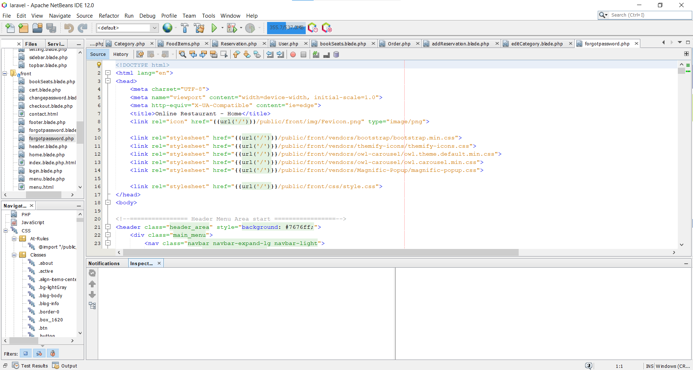

Step 2:

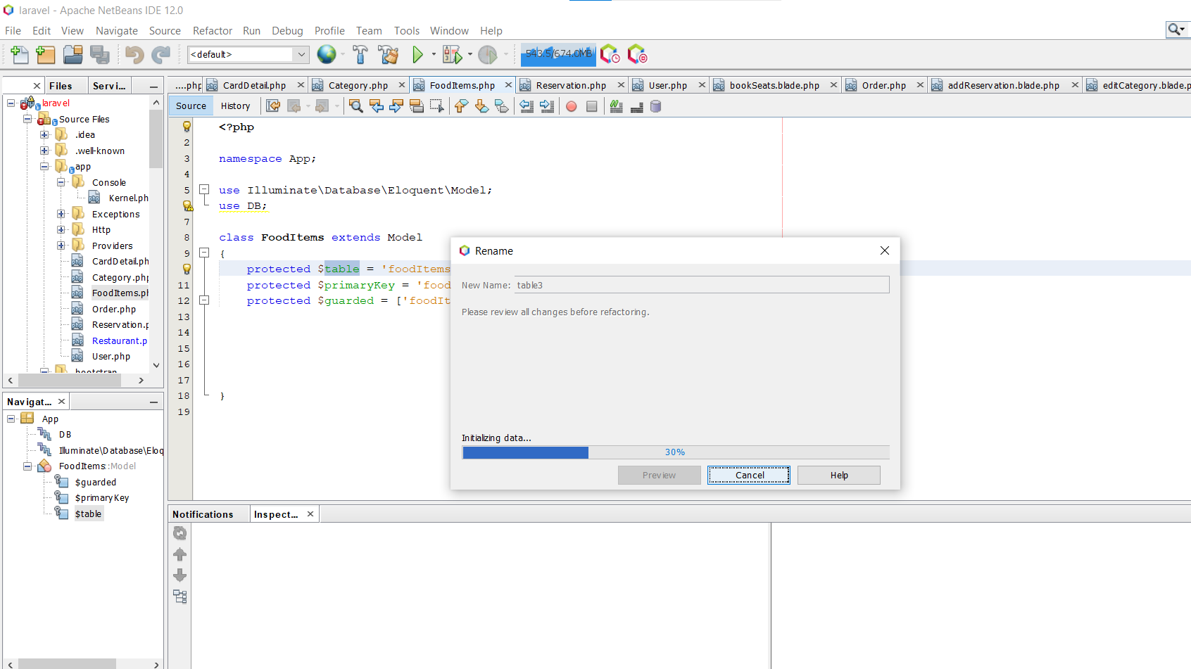

Step:3 Refactoring Done

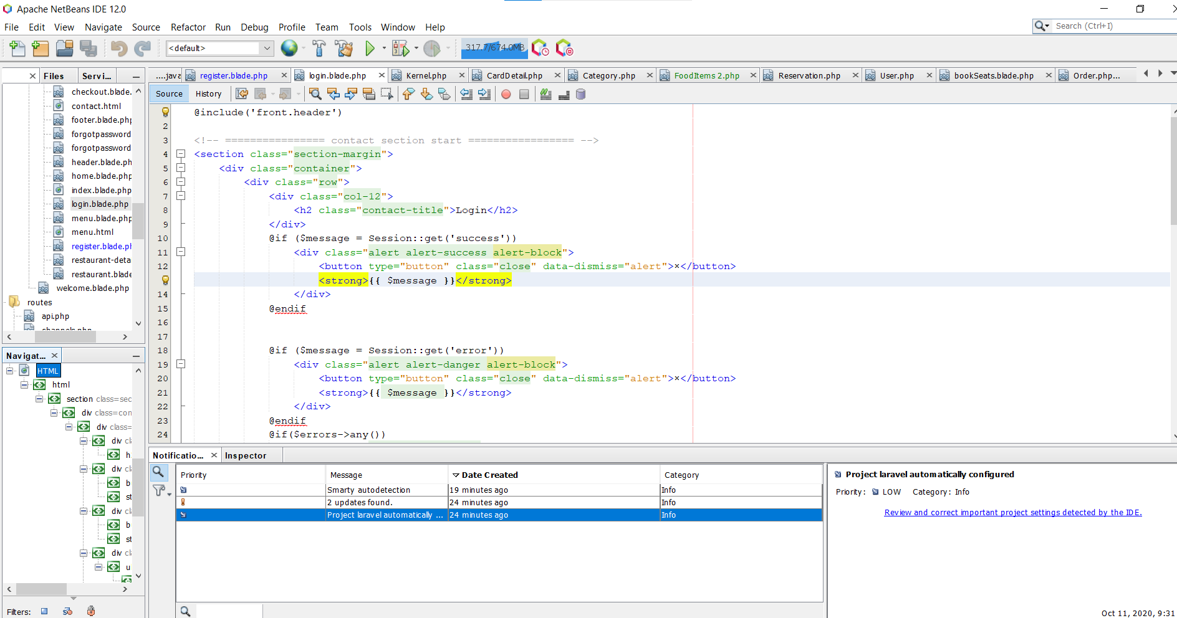

# Configuration Management

Software system and its requirement vary through the development period and use. Configuration management is associated with the policies, processes, and tools for tracking the changing software systems.

We have performed different changes process throughout the development period and all the process are captured with the help of configuration Management.

25.1 CM_activities.eps

## Version management

Version Management is also called as a version Control. Itis the process of keeping the records of different versions of software Components. It is used to manage the code lines and baselines. Simply it is widely used to track the changes to source code and changes made to system by different developers do not interfere with each other

We have used the distributed version control system i.e. git for the development and version Control of app. We have the central repository on the git hub and every member cloned the repository to their local computer and works on a different branch. Every member have committed their changes on their branch and once the testing is performed with the committed code, it is merged with the original repository.

25.8 Branching Merging (25.9).eps

# GitHub link

GitHub Link: <https://github.com/nihalmaredia/online-food>

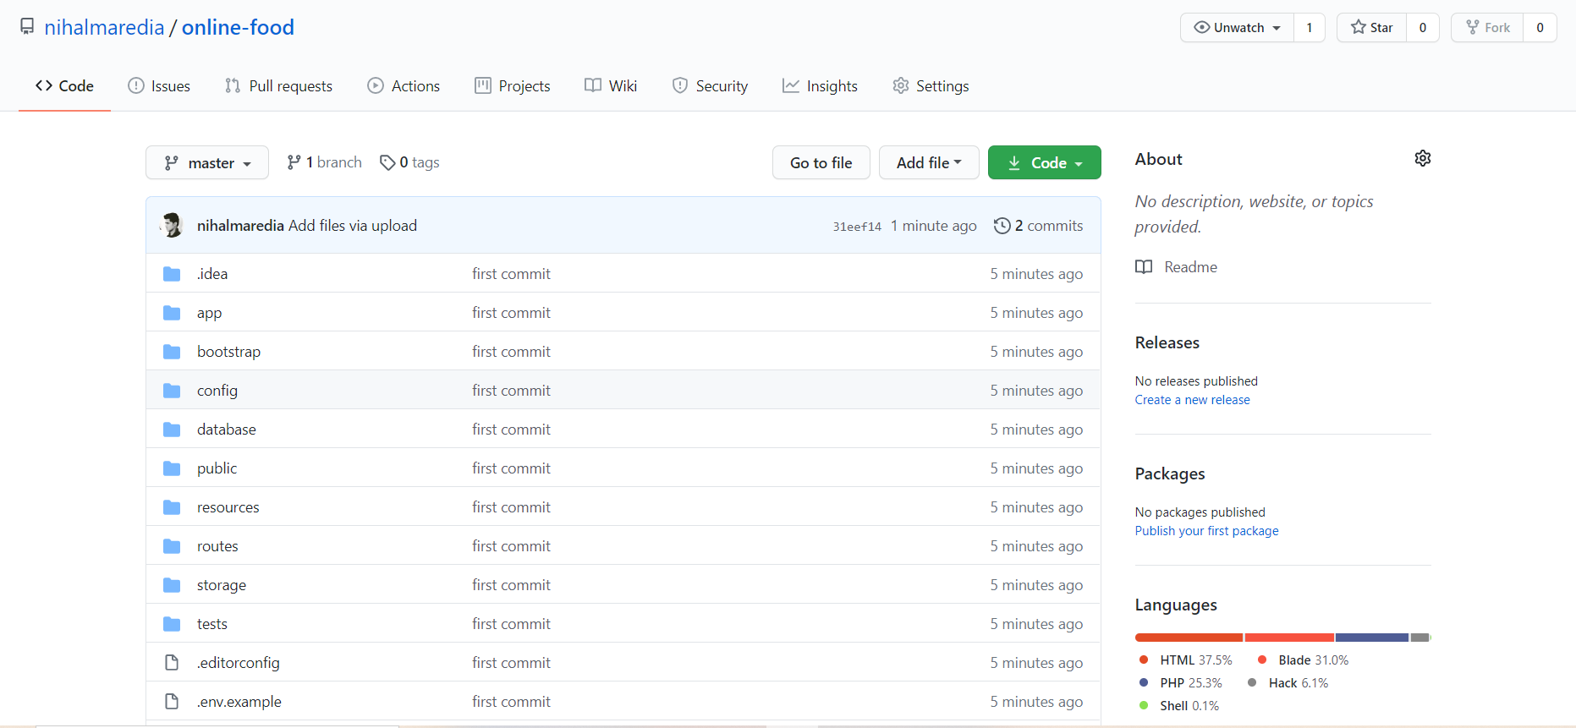

# References

https://cs.uwaterloo.ca/~m2nagapp/courses/CS446/1195/Arch\_Design\_Activity/ClientServer.pdf.